Index

|  |  |  |  |
| --- | --- | --- | --- |
| Practical No. | Practical Description | Date | Sign |
| 1 | To understand the creation and management of users and groups, and working with permissions and advanced permission. |  |  |
| 2 | Working with Console, RPM, and Yum. |  |  |
| 3 | Configuring and Managing Storage. |  |  |
| 4 | Configuring and Enabling Infrastructure Services. |  |  |
| 5 | To understand and configure the OpenSSH server and client on a Linux system for secure remote communication. |  |  |
| 6 | To configure an NFS server and client so that the client can mount and access a directory shared by the server over the network. |  |  |
| 7 | To install, configure, and test an FTP (File Transfer Protocol) server and client on Linux for file sharing over a network. |  |  |
| 8 | To configure a Samba server on a Linux system and access shared directories from Linux/Windows. |  |  |
| 9 | Configuring a DHCP Server. |  |  |
| 10 | Configuring a Web Server. |  |  |
| 11 | Configure Mail Server using Sendmail. |  |  |
| 12 | Configure cron, anacron, and AT. |  |  |
| 13 | Securing Server with iptables. |  |  |
| 14 | Working with GPG (Cryptographic Services). |  |  |
| 15 | Programs on Shell scripting. |  |  |

**Practical 1**

Aim: To understand the creation and management of users and groups, and working with permissions and advanced permission.

Step 1: Creating and Managing Users

Create 2 student users and 2 staff users and setting passwords for each user.

# Create student users useradd -m student1 useradd -m student2

# Set passwords

passwd student1

Output:

passwd student2

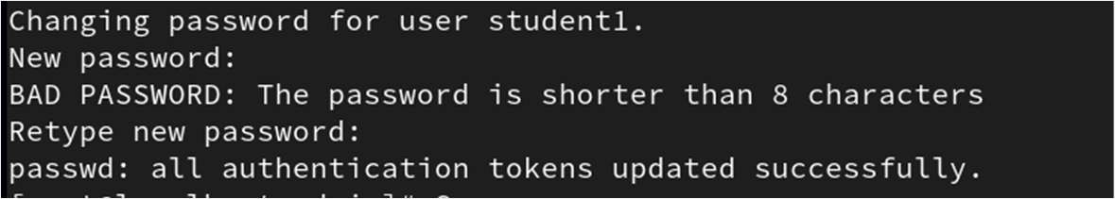

# Create staff users useradd -m staff1 useradd -m staff2

# Set passwords passwd staff1 passwd staff2

Step 2: Creating and Managing Groups

Create student and staff groups, then assign users to respective groups.

# Create groups

groupadd students groupadd staff

# Add users to groups

Adding student1 and student2 to Group student

usermod -aG students student1 usermod -aG students student2 Adding staff1 and stadd2 to Group staff

usermod -aG staff staff1 usermod -aG staff staff2

Verification: Check group membership with:

groups student1

Output:

groups staff1

Output:



Step 3: Creating Folders for Each Group

Create two folders, one for students and one for staff.

# Create folders

mkdir /home/students_folder mkdir /home/staff_folder

# Assign group ownership

chown :students /home/students_folder chown :staff /home/staff_folder

# Set permissions

chmod 770 /home/students_folder chmod 770 /home/staff_folder

Output: Verify using ls command

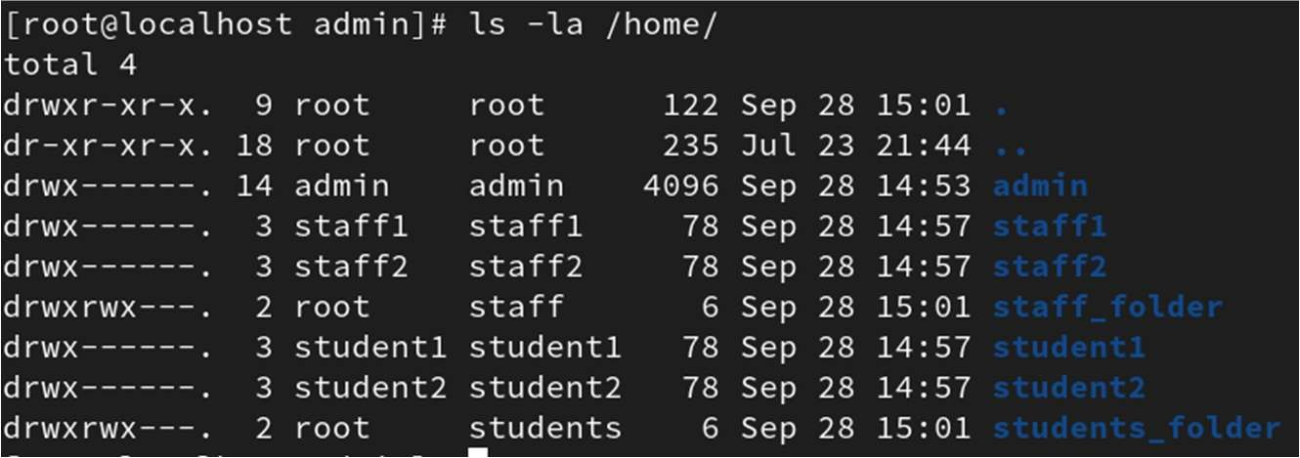

Explanation:

770 means: Owner: read, write, execute | Group: read, write, execute | Others: no access Verify: Testing Access Permissions

Login as student1 and staff1 and try accessing both folders.

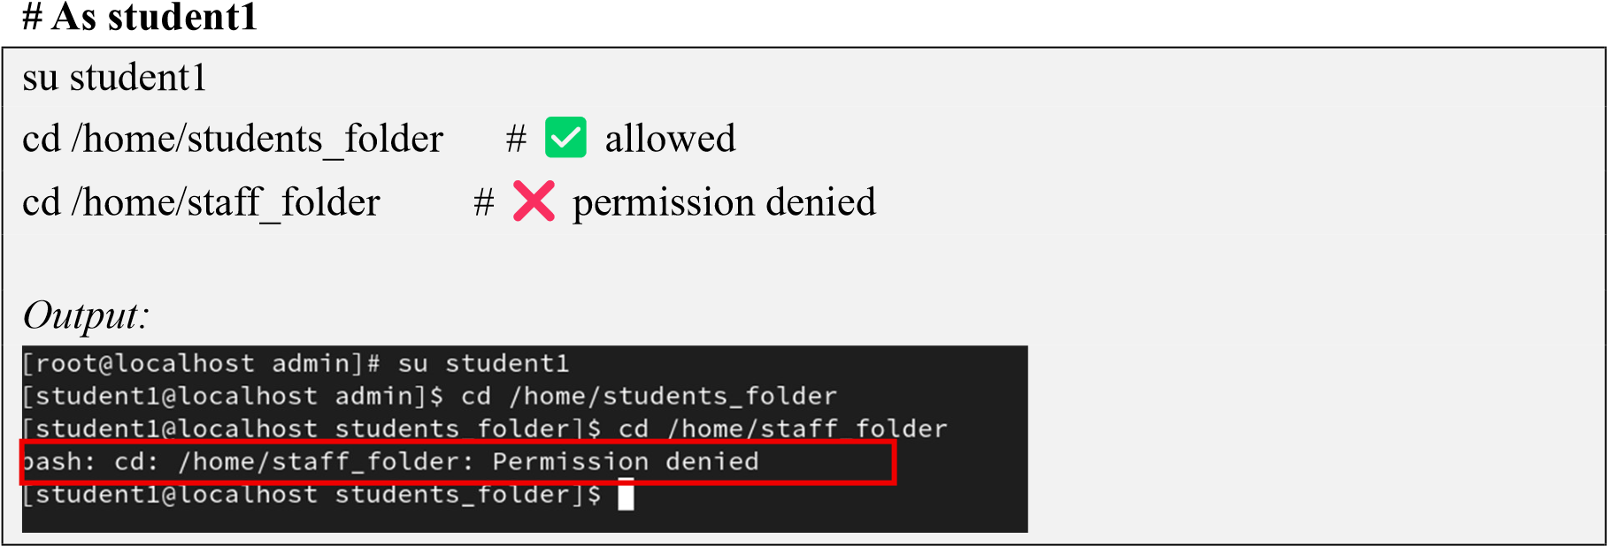

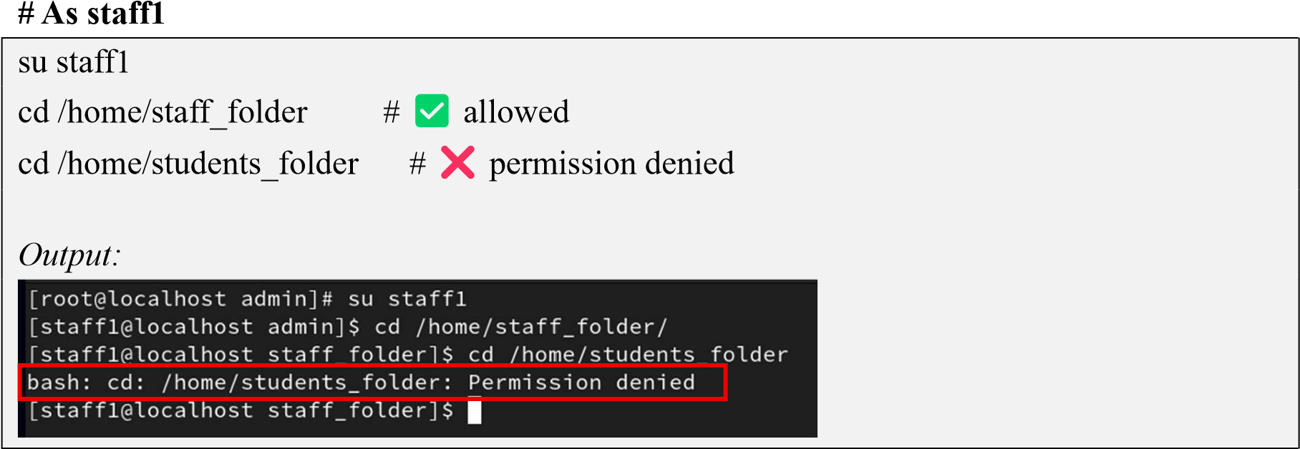

Working with Advanced Permissions

1. Setgid on Directories:

Ensure all files created in the folder inherit the group of the directory.

chmod g+s /home/students_folder

chmod g+s /home/staff_folder

Output:

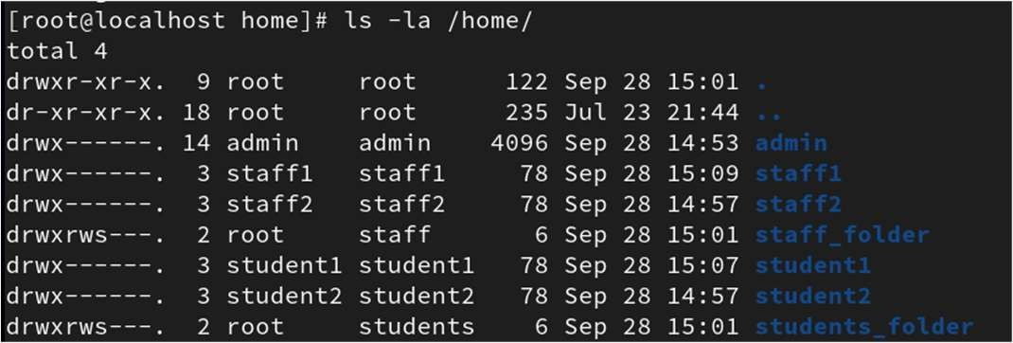

➔ Now any file created inside will inherit the group (students or staff), not the user’s

primary group.

1. Sticky Bit on a Shared Directory:

Let’s make a shared folder where only owners can delete their files.

mkdir /home/shared

chmod 1777 /home/shared

Output:

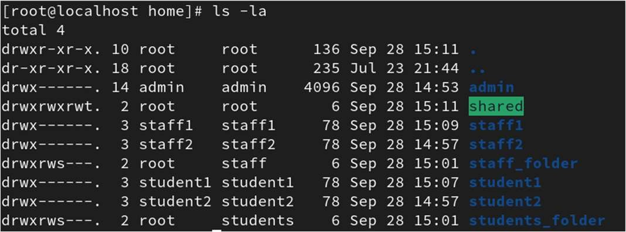

➔ 1 at the beginning is the sticky bit.

➔ Sticky bit ensures users can only delete their own files in a shared directory.

Verify:

1. Login as Student1 and Create a file inside shared directory

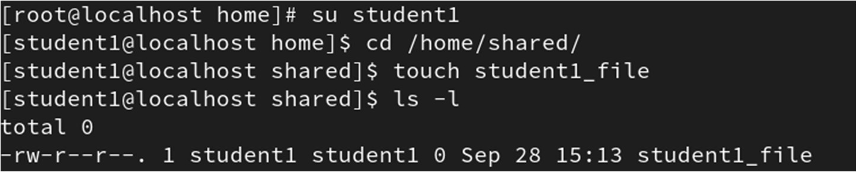

1. Switch to Staff1 and try to delete same file

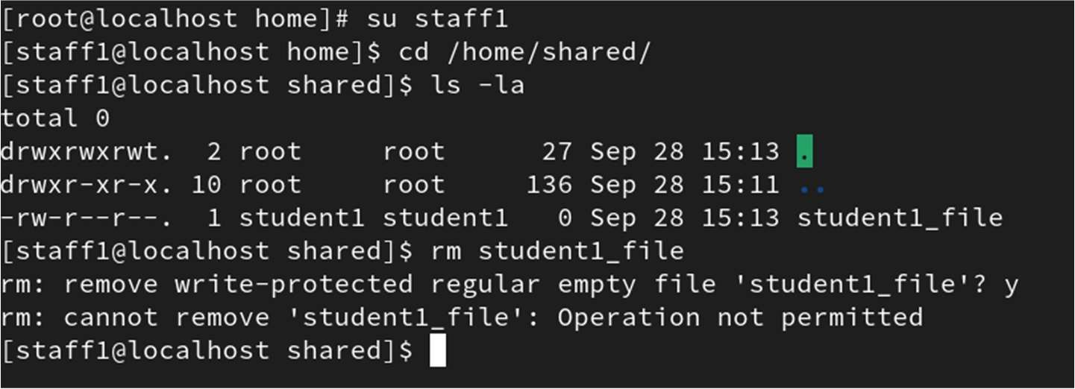

**Practical 2**

Aim: Working with Console, RPM, and Yum

a. Managing Console and Gaining Privileges

The console is your primary interface to interact with the Linux operating system—think of it as the command line’s home base. When working on a Linux server or desktop, you’ll often start in the terminal console to issue commands directly.

One critical concept you must grasp early is user privileges. Linux enforces security by restricting certain operations to privileged users. The superuser, or root, has unrestricted access, while regular users have limited rights to protect the system.

To perform administrative tasks, you need to gain elevated privileges:

→ ‘su’ (substitute user) command lets you switch to the root user or another user if you know their password.

|  |  |
| --- | --- |
| Command: su Output:      Note: Switching to Root User required password | Command: su admin Ouput:      Note: Switching from root to another user doesn’t required password |

→ ‘sudo’ allows a permitted user to execute commands as the superuser or another user, based on configuration in /etc/sudoers.

Execute useradd command with prefix as sudo from a admin user

Command:

sudo useradd testuser

Output:

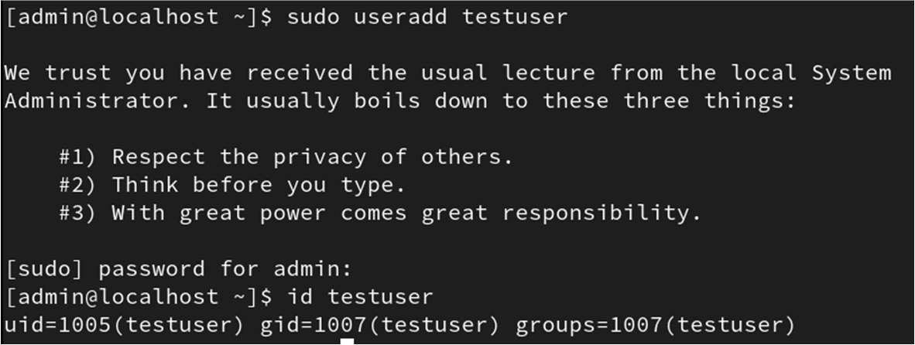

Remember: Using root privileges carelessly can harm the system. Always think twice before executing commands as root!

1. Working with RPM

RPM stands for Red Hat Package Manager, a powerful command-line tool for managing software packages on RPM-based distributions like CentOS, Fedora, and Red Hat Enterprise Linux.

Installing a package

:

rpm -ivh package-name.rpm

Example: Installing httpd package from RHEL DVD Media

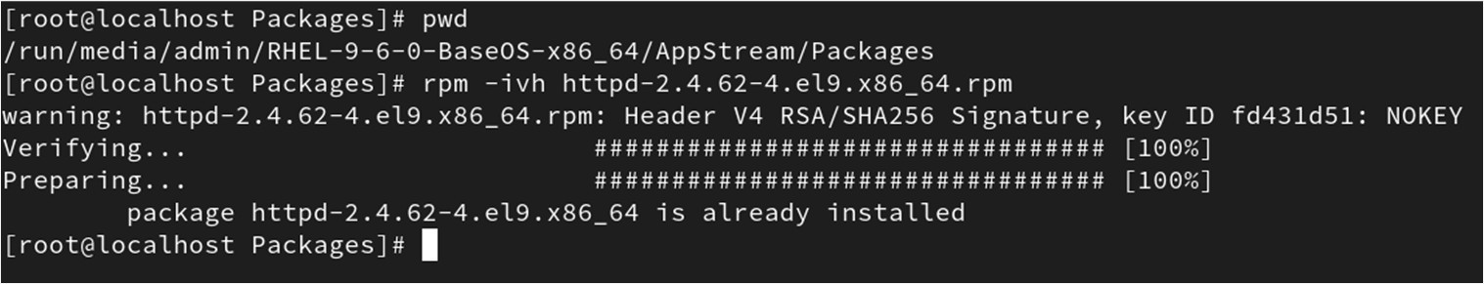

Removing a package

:

rpm -e package-name

Example : Removing rpcbind package

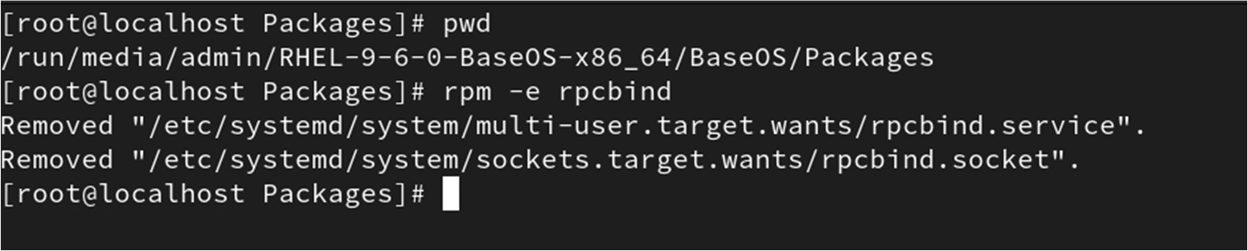

Querying installed packages

:

rpm -qa | grep package-name

Example : Finding httpd package

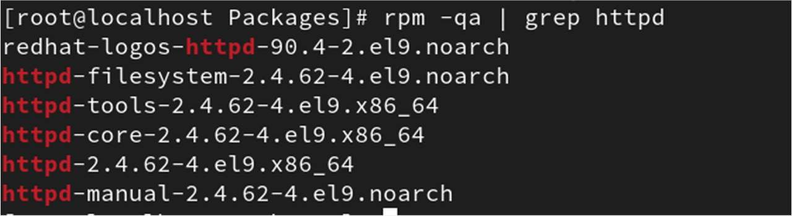

RPM is great for fine-grained control but doesn’t automatically handle dependencies, which can be a headache if the package requires other packages.

1. Working with Yum

To ease the pain of manual dependency handling, we use Yum, a higher-level package manager that works with RPM but automatically resolves dependencies.

Yum connects to online repositories to install, update, and remove packages seamlessly.

→ Create Own Repository for YUM

Step 1: Attach ISO (or insert DVD)

If you're using a virtual machine attach the RHEL ISO to the Controller IDE as demonstarted below

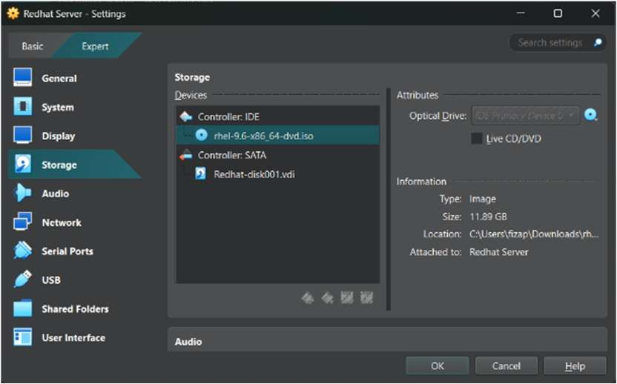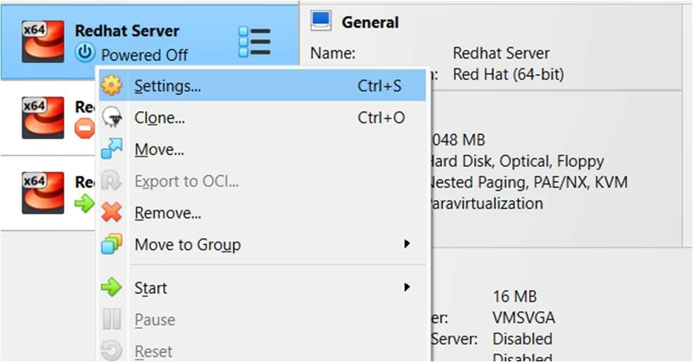

Step 2: Find the mount path of using lsblk command

Step 3: Create

/myrepo

and copy contents

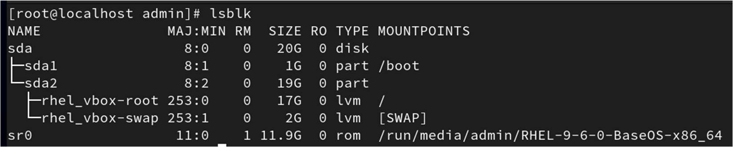

sudo mkdir -p /myrepo

Step 4: Copy AppStream and BaseOS directories with their metadata from DVD to myrepo directory

cd /run/media/admin/RHEL-9-6-0-BaseOS-x86_64/ cp -rv BaseOS/ /myrepo cp -rv AppStream/ /myrepo

Step 5: Create local repo config file (myrepo.repo)

Create a single .repo file pointing to both BaseOS and AppStream.

gedit /etc/yum.repos.d/myrepo.repo

Add Configuration as below in myrepo.repo file :

|  |
| --- |
| [baseos] name=RHEL 9 - BaseOS baseurl=file:///myrepo/BaseOS/ enabled=1 gpgcheck=0    [appstream] name=RHEL 9 - AppStream baseurl=file:///myrepo/AppStream/ enabled=1 gpgcheck=0 |

Save and close the file

Step 6: List all enabled repositories to verify

yum repolist

Output:

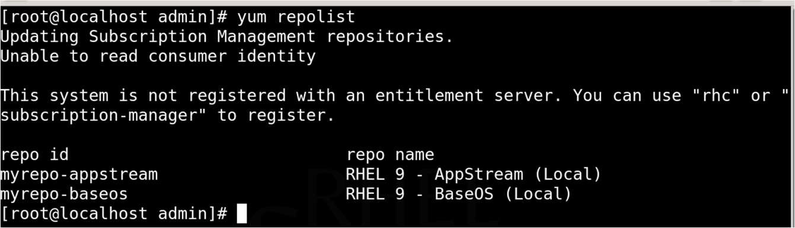

Step 7: Install and Remove Packages using YUM

yum install dhcp-server -y

Output:

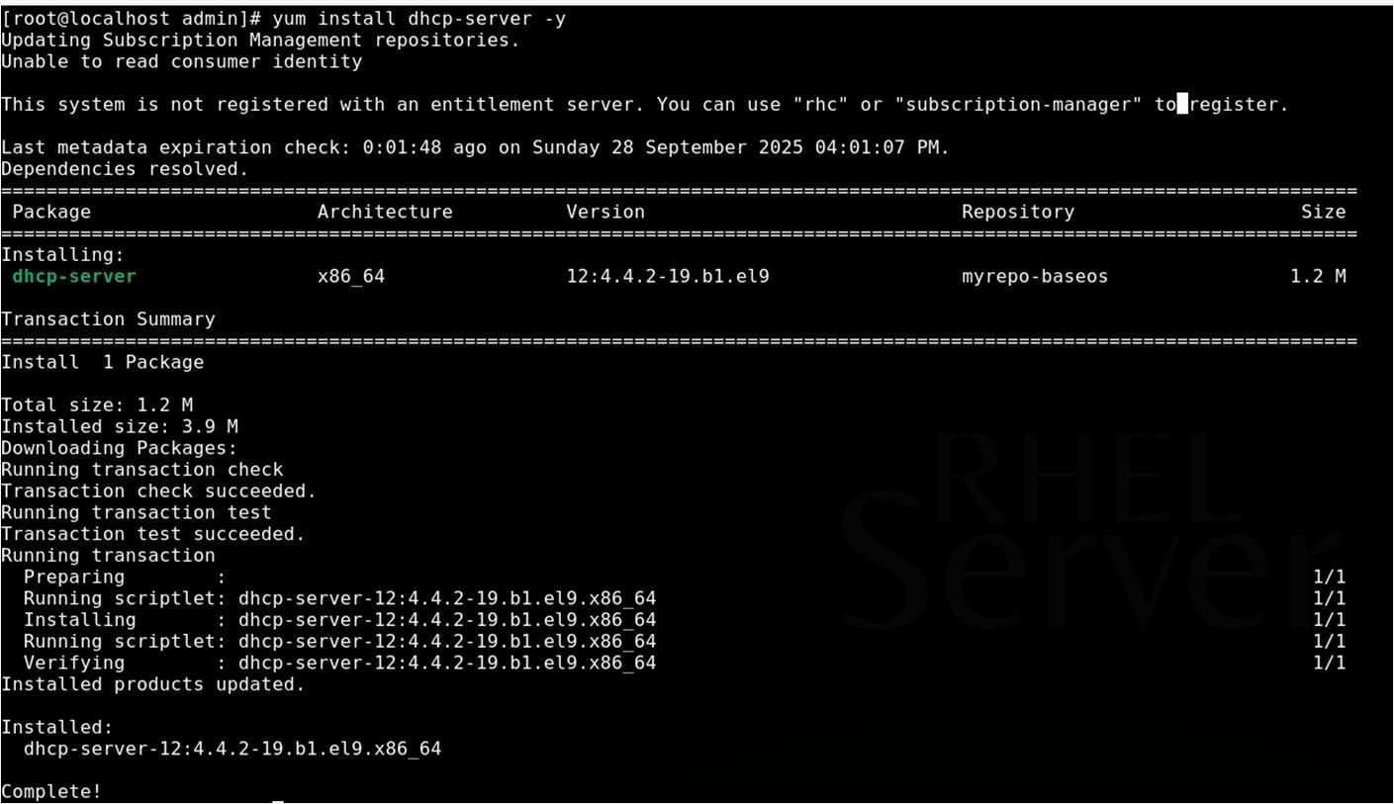

yum remove dhcp-server -y

Output:

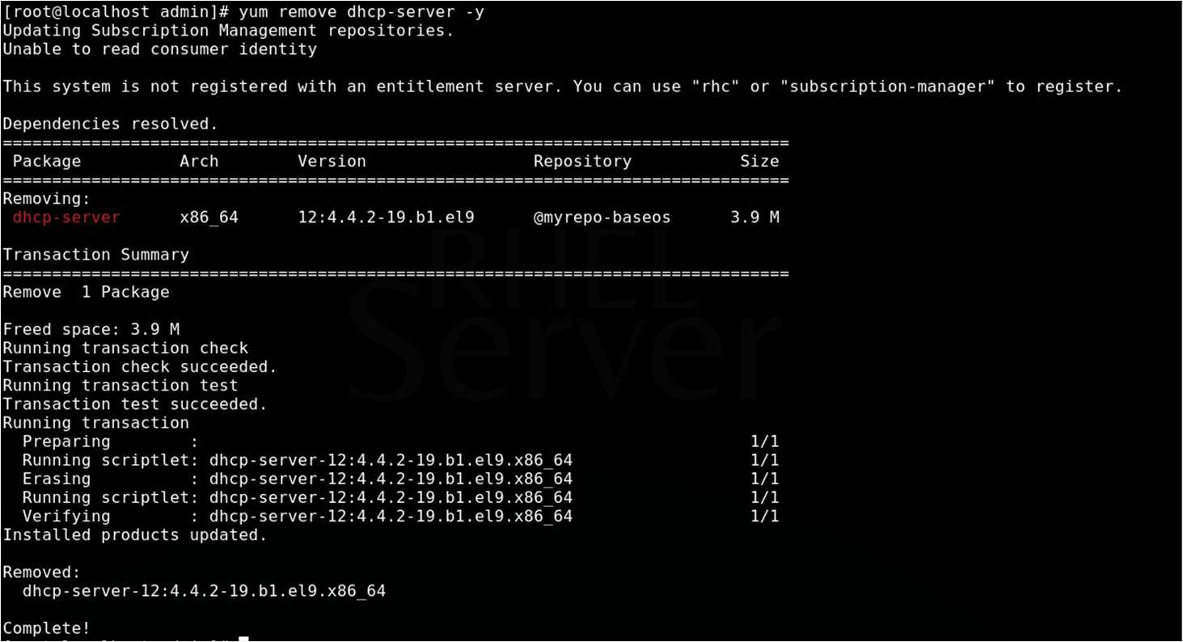

**Practical 3**

Aim: Configuring and Managing Storage

Objective:

1. Creating two 1GB partitions
2. Creating a file system on each partition

Attaching 2 GB Virtual Disk to Virtual Machine

- Go to the Settings → Storage → Click on Add hard disk → Click on Create → Set Size as 2GB and Type as VHD

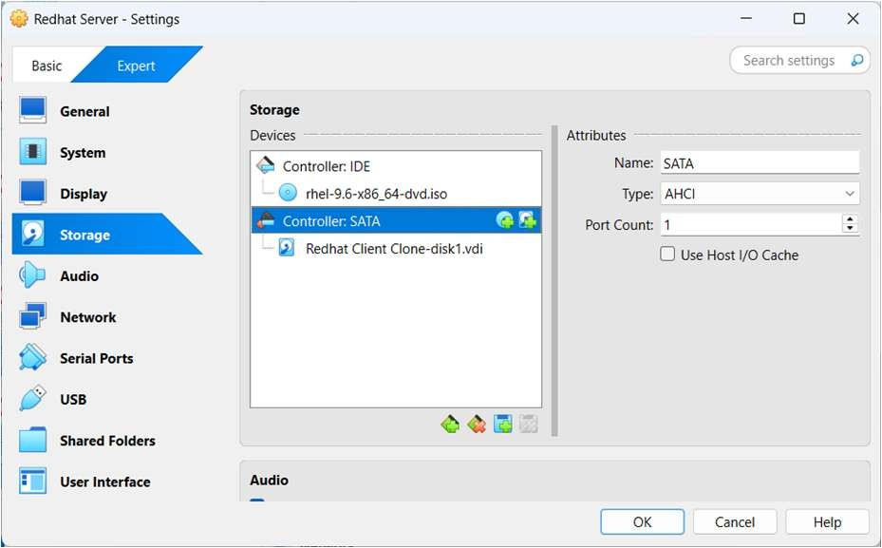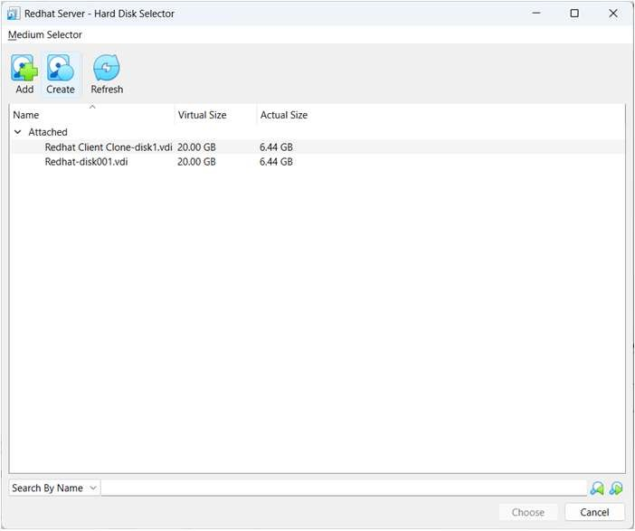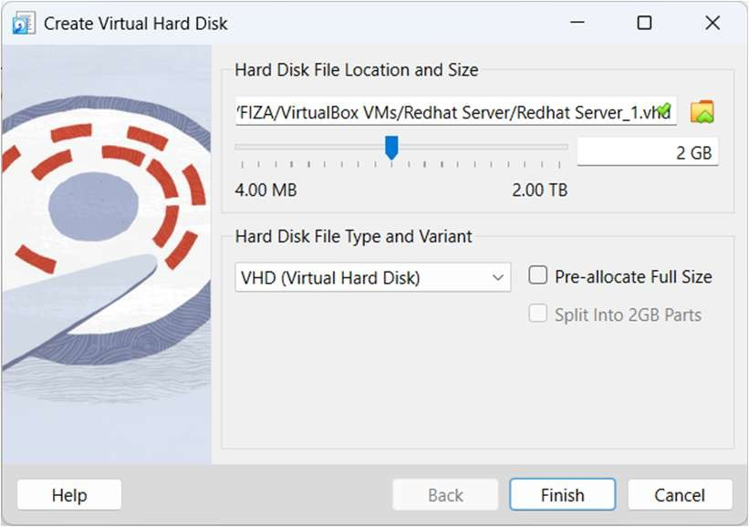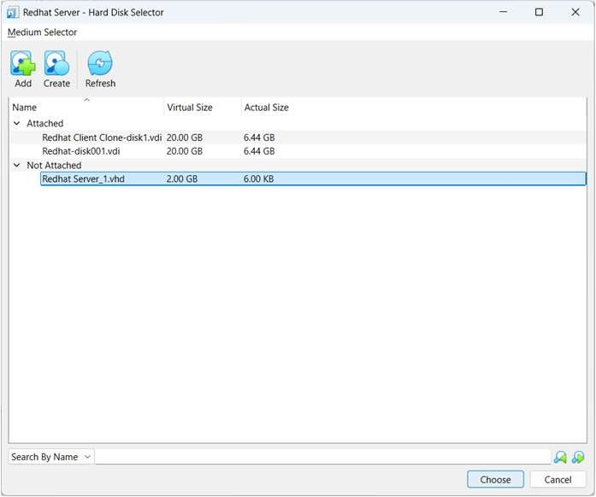

Step 1. Verified the New Disk

After attaching the 2GB disk to VM, Use lsblk to confirm it appeared as /dev/sdb:

lsblk

Output:

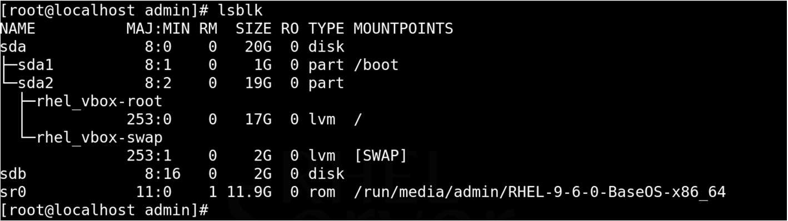

Perfect — /dev/sdb was new unpartitioned 2GB disk.

Step 2. Created Two 1GB Partitions

Use fdisk Command to create two partitions:

fdisk /dev/sdb

In fdisk, do the following:

* + Pressed n → to create a new partition o Selected p for primary o Partition number: 1 o Accepted default first sector o Set +1G as the last sector

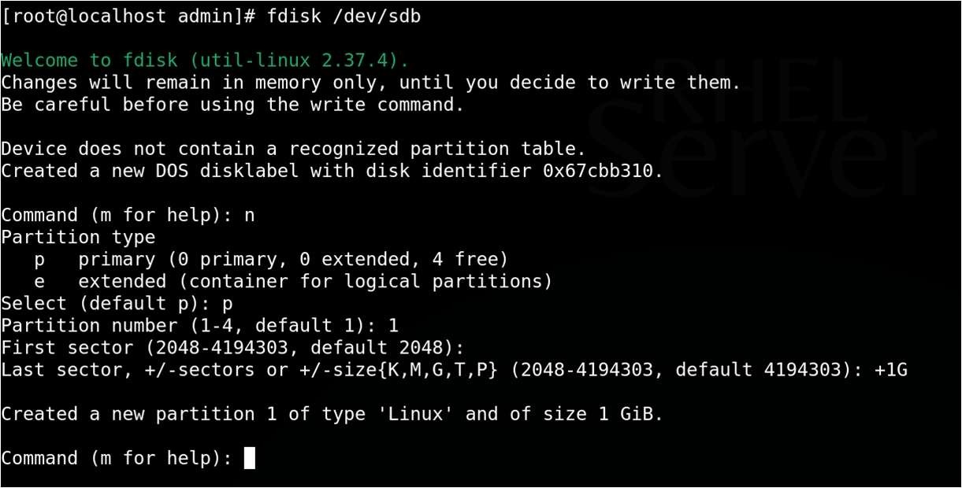

* + Repeated the above to create Partition 2 (using the remaining space)

Then Save the changes:

* + Pressed w → to write and exit

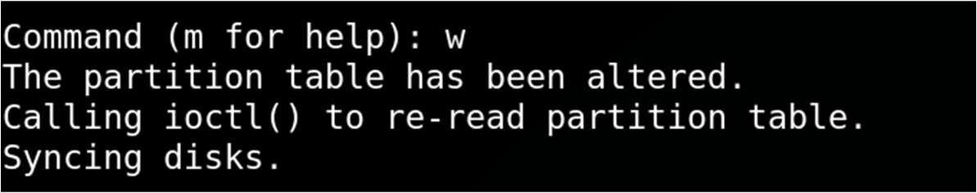

Step 3. Checked the Partition Table

lsblk

Output:

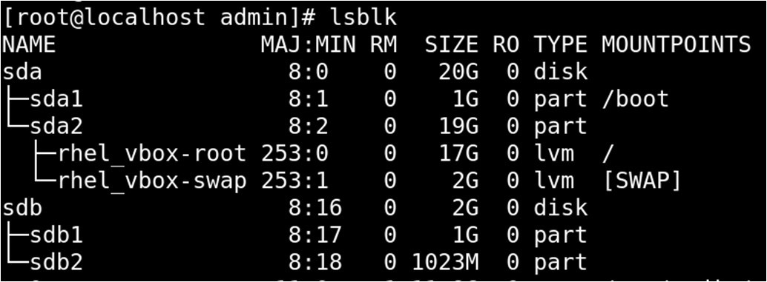

Now we had two 1GB partitions: /dev/sdb1 and /dev/sdb2

Step 4. Created File Systems

Format each partition with the ext4 filesystem:

mkfs.ext4 /dev/sdb1 mkfs.ext4 /dev/sdb2

Output:

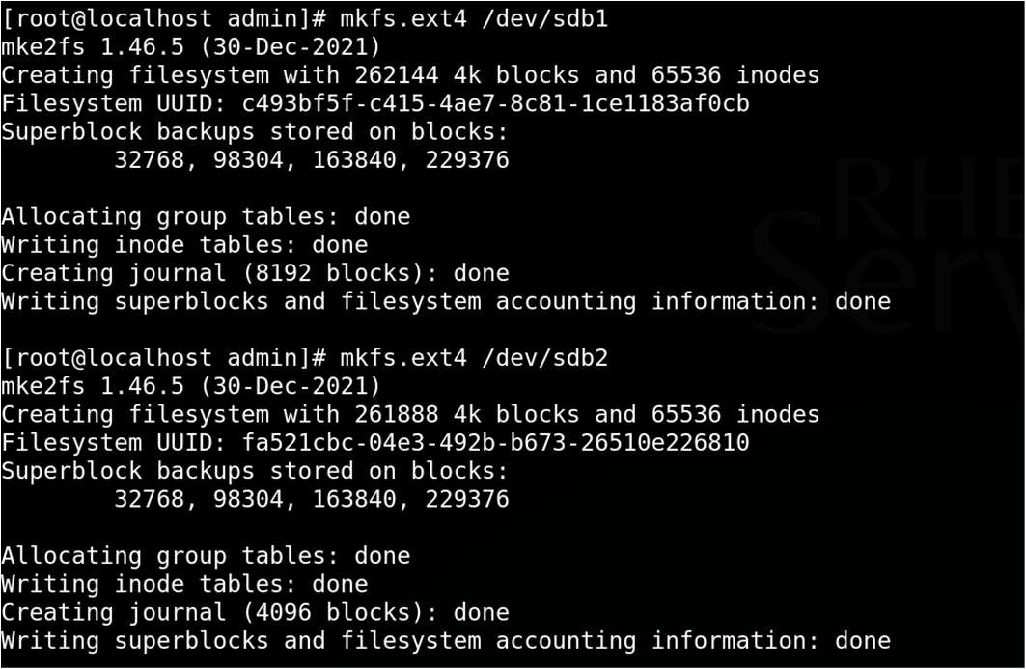

Step 5. Mount and Verify:

|  |
| --- |
| mkdir /mnt/part1 mkdir /mnt/part2    mount /dev/sdb1 /mnt/part1 mount /dev/sdb2 /mnt/part2    df -h |

Output:

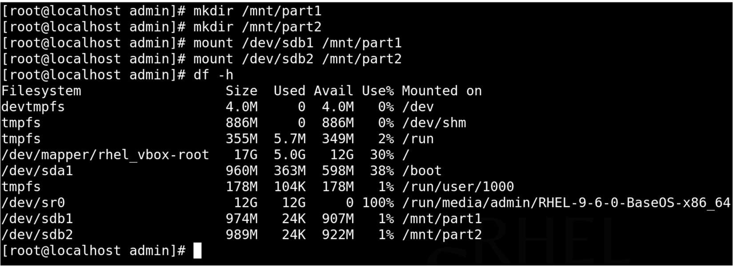

To Unmount use Command:

umount /mnt/part1 unmount /mnt/part2

**Practical 4**

Aim: Configuring and Enabling Infrastructure Services

1. View All Services and Their Runlevel Status

chkconfig --list # For older version

systemctl list-unit-files --type=service # For RHEL 7.0+

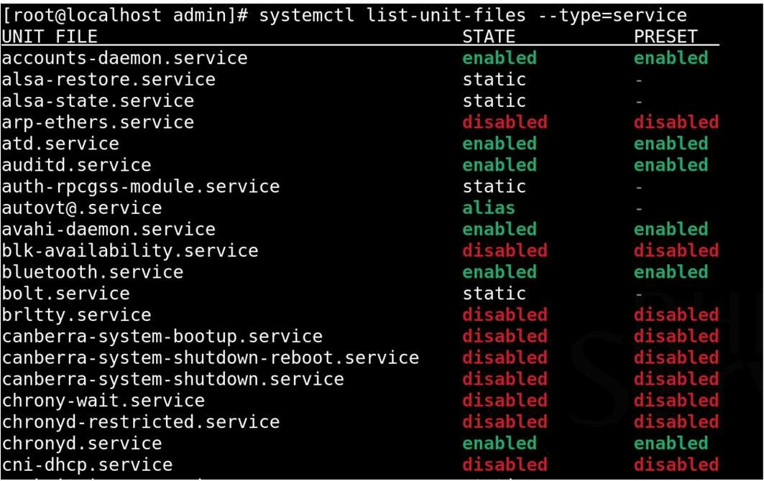

This command displays all the registered services and whether they are enabled (on) or disabled (off)

1. Enable a Service to Start at Boot

chkconfig httpd on systemctl enable httpd

This enables the Apache web server (httpd) to start automatically at system boot.

1. Disable a Service from Starting at Boot

chkconfig httpd off systemctl disable httpd

Disables the Apache web server from starting at boot time.

1. Start or Stop a Service Manually

Since chkconfig does not start or stop services immediately (it only configures boot behavior), we use the service command:

service httpd start # Start the service now service httpd stop # Stop the service now chkconfig only affects whether a service starts automatically during system boot; it does not control its current running state.

Runlevels:

o 0 = Halt o 1 = Single-user mode o 3 = Multi-user, no GUI o 5 = Multi-user with GUI o 6 = Reboot

To view the current runlevel:

runlevel

Output:

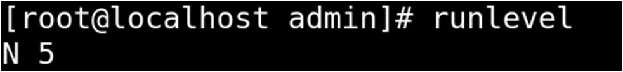

**Practical 5**

Aim: To understand and configure the OpenSSH server and client on a

Linux system for secure remote communication

Part 1: SSH Password Based Authentication

1. Install SSH Server (If not Installed)

yum install openssh-server

1. Start and Enable SSH

service sshd start



1. Check SSH Status

service sshd status

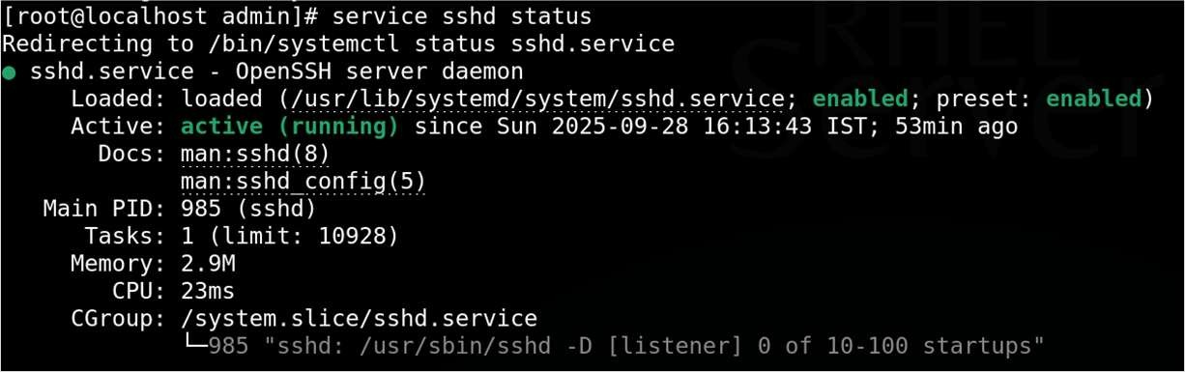

1. SSH Configuration Edit config:

gedit /etc/ssh/sshd_config

Recommended changes:

PermitRootLogin no

PasswordAuthentication yes

AllowUsers admin

1. Restart SSHD Service

service sshd restart

1. Check IP Address of the Server

ifconfig

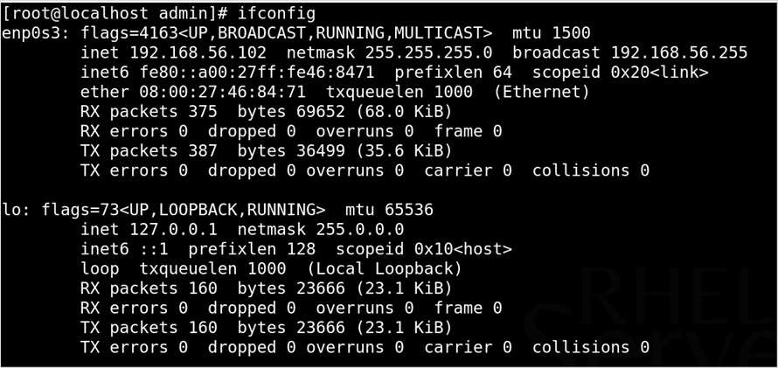

1. Verify: Connect the Server using Client Machine

ssh admin@192.168.56.2

here admin is username and 192.168.6.2 is server Ip address

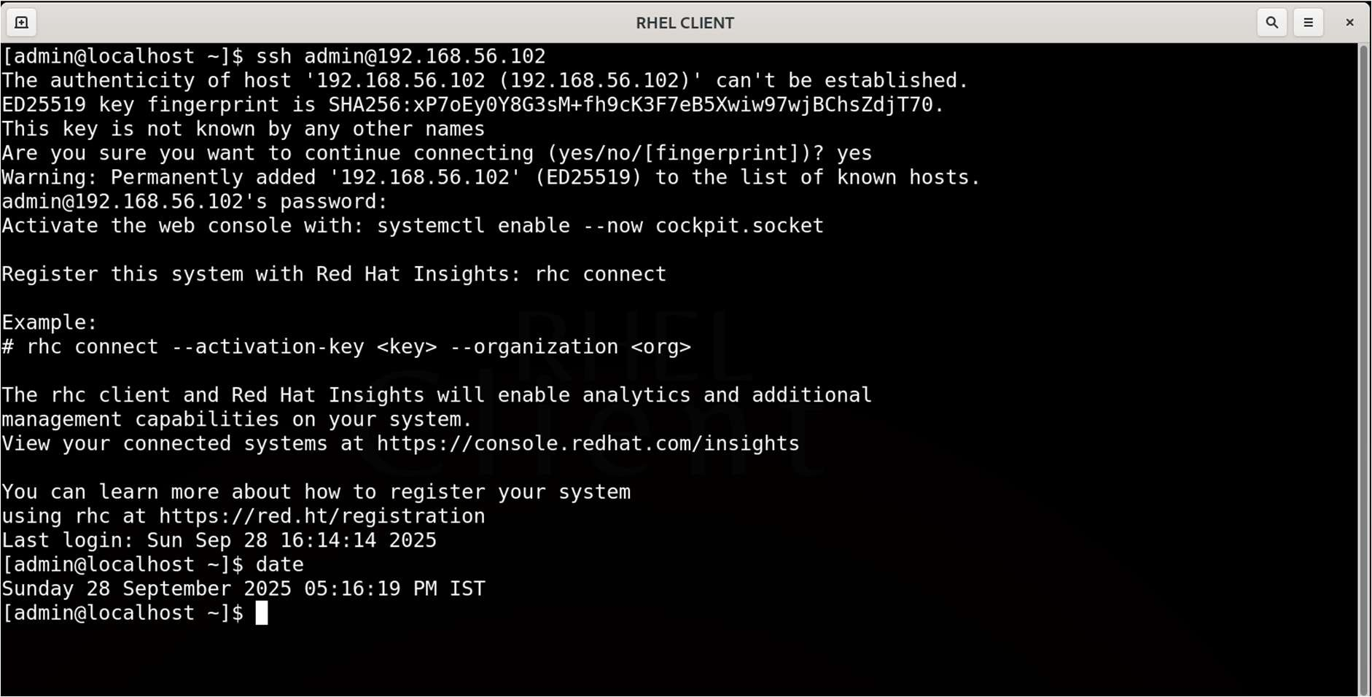

Part 2: SSH Key-Based Authentication

1. On Client Side, Generate Key Pair using ssh-keygen command

ssh-keygen -t rsa

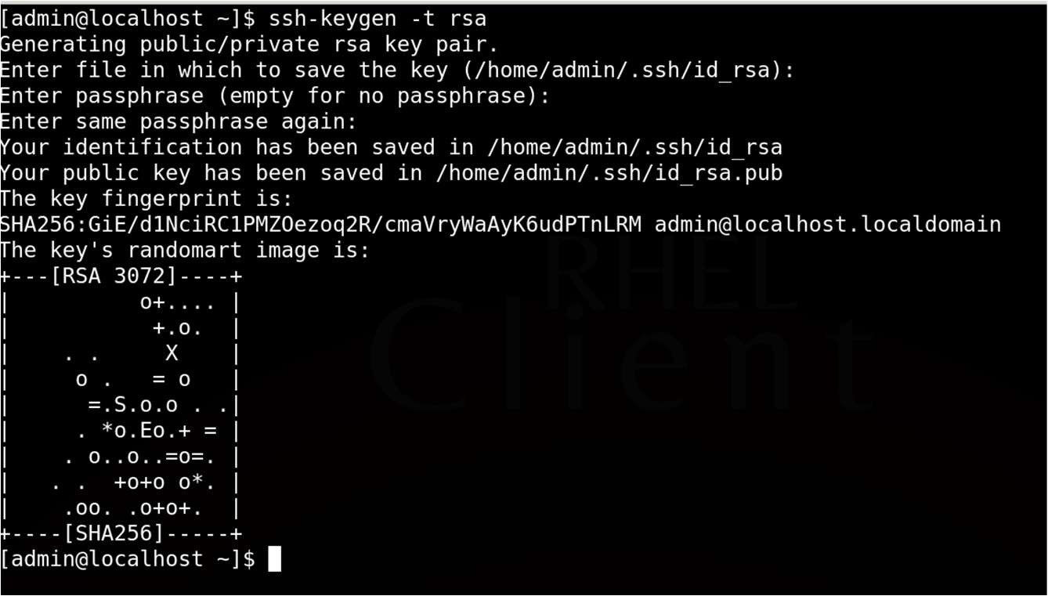

1. Transfer Public Key (id_rsa.pub) to Server using ssh

ssh-copy admin@192.168.56.102

Hit enter and you need to enter the password for admin user and key will be copied from client to server’s .ssh/authorized_keys file

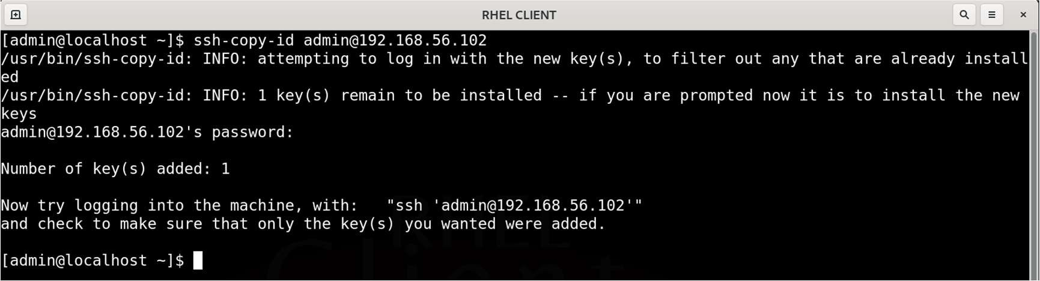

1. Verify the Key file on Server

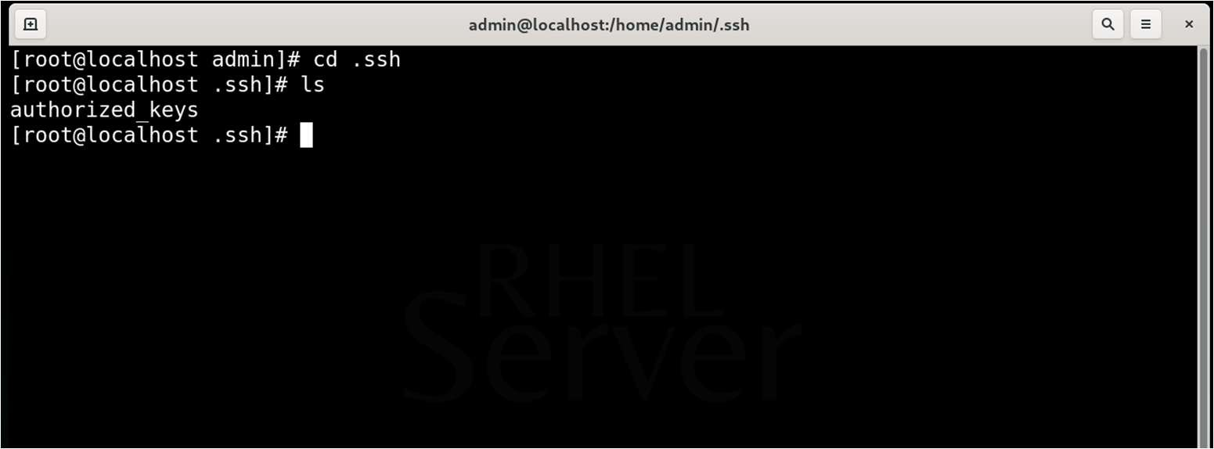

1. Edit the SSHD Config File On Server as below:

gedit /etc/ssh/sshd_config

Recommended Changes:

PermitRootLogin no

PasswordAuthentication no

AllowUsers admin

1. Restart SSHD Service

service sshd restart

1. Connect Server from Client Machine

ssh admin@192.168.56.102

Hit enter and now no password is prompted because of key-based auth

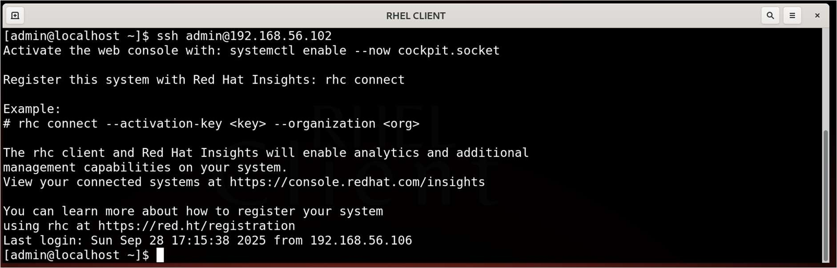

**Practical 6**

Aim: To configure an NFS server and client so that the client can mount and access a directory shared by the server over the network.

Prerequisites

* + Two Linux systems:

o One to act as the NFS Server o One to act as the NFS Client

* + Both systems must be on the same network and able to communicate

Part A: Configuration on the NFS Server

Step 1: Install NFS Packages

On the server system, install the required NFS utilities:

yum install -y nfs-utils

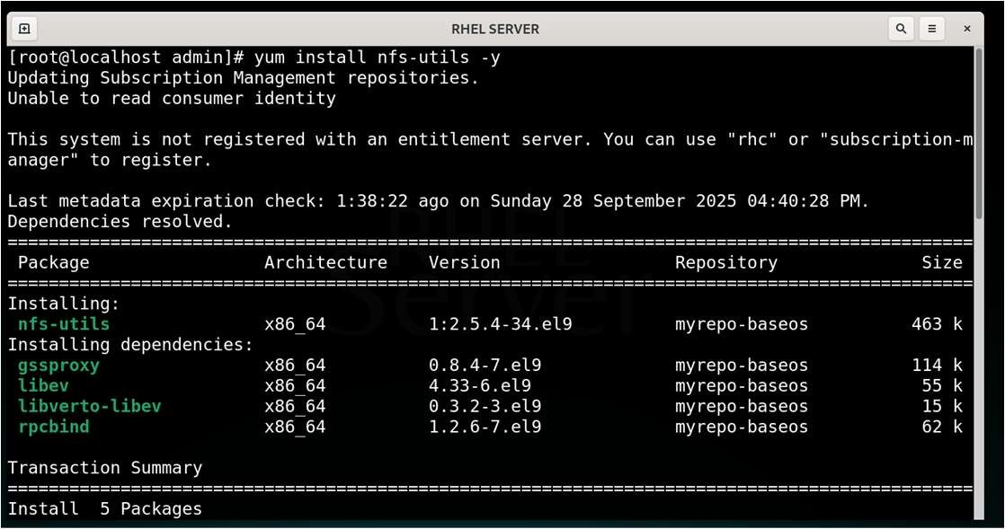

Step 2: Create a Directory to Share

Create a directory that will be shared over the network:

mkdir -p /nfs_share chmod 755 /nfs_share



Step 3: Configure the /etc/exports File Edit the NFS exports configuration file:

gedit /etc/exports

Add the following line:

/nfs_share *(rw,sync,no_root_squash)

Explanation of options:

* * allows access from any host.
* rw allows read and write access.
* sync ensures changes are written to disk before the server responds.
* no_root_squash allows root on client to retain root privileges on the share.

Step 4: Start NFS Services Start the required services:

service rpcbind start service nfs-server start

Check the service status to confirm they are running:

service nfs-server status

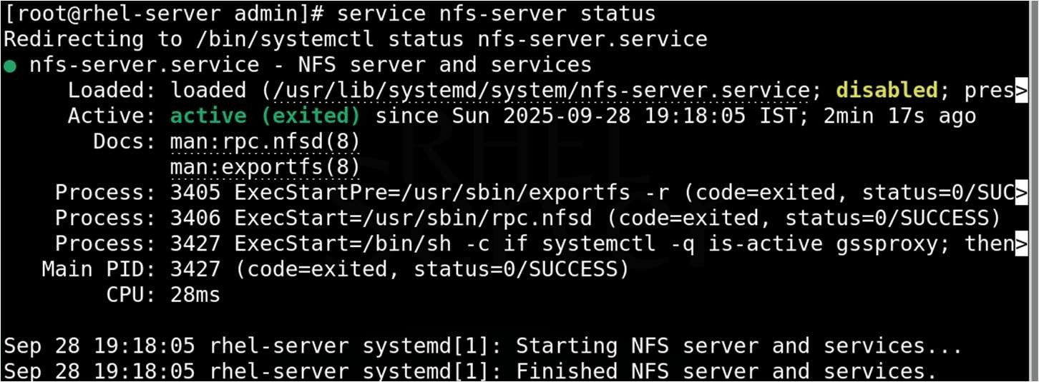

Step 5: Export the Shared Directory

Apply the export settings and to verify exports:

exportfs -rav

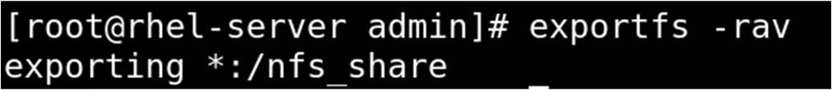

Step 6: Configure the Firewall

Allow NFS-related services through the firewall:

firewall-cmd --permanent --add-service=nfs firewall-cmd --permanent --add-service=rpc-bind firewall-cmd --permanent --add-service=mountd firewall-cmd --reload

Part B: Configuration on the NFS Client

Step 1: Install NFS Utilities

Install the NFS client utilities:

yum install -y nfs-utils

Step 2: Display the list of directories exported by an NFS server.

showmount -e 192.168.56.102

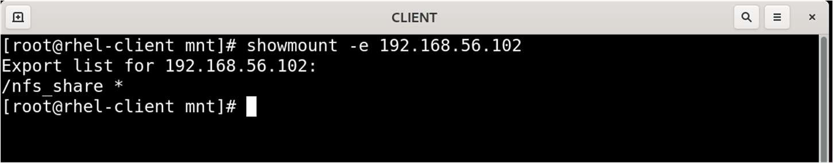

Step 3: Create a Mount Point

Create a directory to use as the mount point for the shared directory:

mkdir -p /mnt/nfsmount

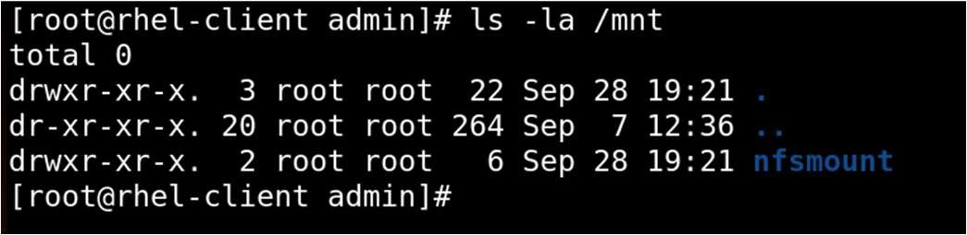

Step 4: Mount the NFS Share

Mount the shared directory from the server to the local mount point:

mount -t nfs 192.168.56.102:/nfs_share /mnt/nfsmount

Replace 192.168.56.102 with the actual IP address of your NFS server.

Step 5: Verify the Mount

Check if the NFS share is mounted correctly:

df -h /mnt/nfsmount

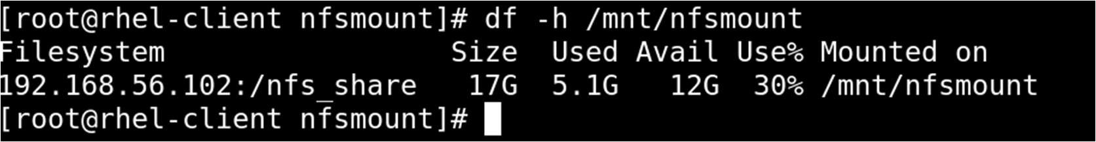

You should see the mount listed with available space information.

Part C: Testing the NFS Setup

1. On the client, create a file in the mounted directory:

touch /mnt/nfsmount/hello

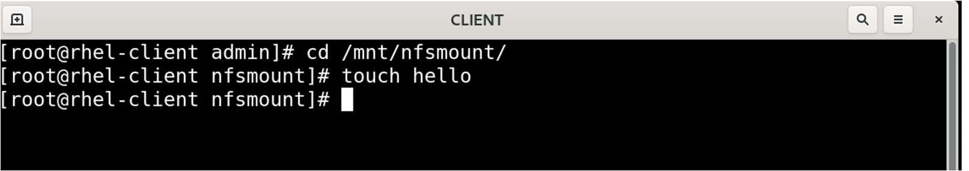

1. On the server, confirm that the file was created in the shared directory:

ls /nfs_share

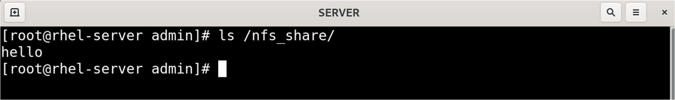

You should see hello file listed on server.

**Practical 7**

Aim: To install, configure, and test an FTP (File Transfer Protocol) server and client on Linux for file sharing over a network.

Part A: Configuring the FTP Server

Step 1: Install vsftpd

On the server, install the FTP server package:

yum install -y vsftpd

Step 2: Start and Enable the FTP Service

service vsftpd start

Verify the service is running:

service vsftpd status

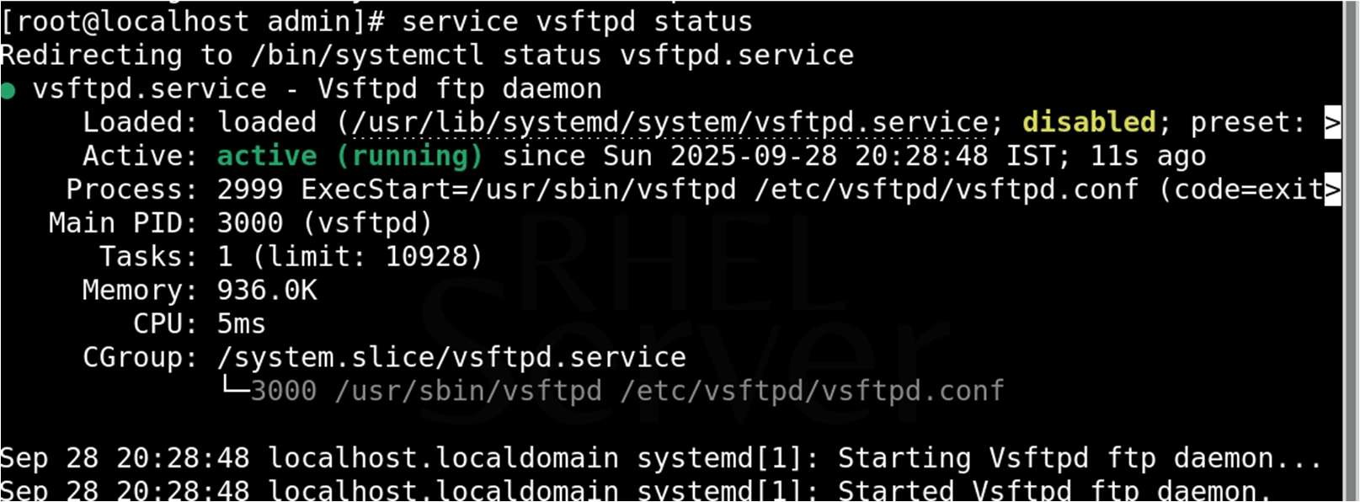

Step 3: Configure the Firewall (If Enabled) Allow FTP service through the firewall:

firewall-cmd --permanent --add-service=ftp firewall-cmd --reload

Step 4: Configure FTP Settings (Optional) Edit the configuration file:

gedit /etc/vsftpd/vsftpd.conf

Key options to check or modify:

anonymous_enable=NO # Disable anonymous login local_enable=YES # Allow local user login write_enable=YES # Allow uploading and editing chroot_local_user=YES # Jail users in their home directory allow_writeable_chroot=YES

After making changes:

service vsftpd restart

Part B: Creating a Test FTP User

You can use an existing user or create a new one for FTP access:

useradd ftpuser passwd ftpuser

Create a file in the home directory:

echo "FTP Test File" > /home/ftpuser/testfile.txt chown ftpuser:ftpuser /home/ftpuser/testfile.txt

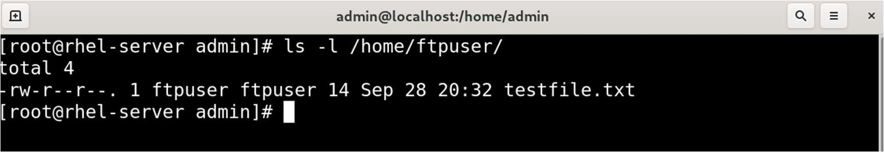

Part C: Accessing FTP from the Client

Step 1: Install FTP Client

On the client, install the FTP client utilities:

yum install -y ftp

Step 2: Create a file to upload on server

touch client_file

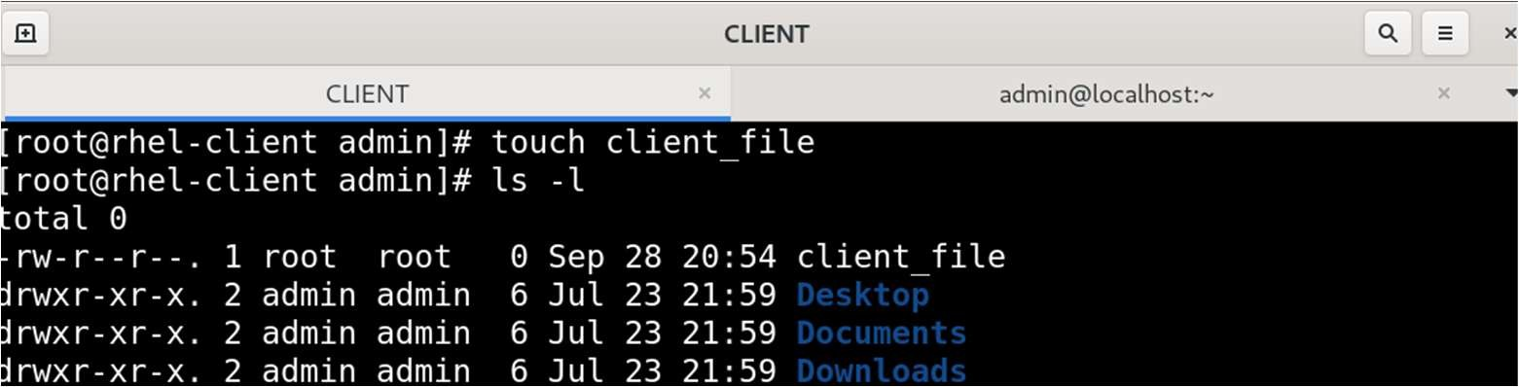

Step 3: Connect to the FTP Server

ftp 192.168.56.102

Replace 192.168.56.102 with the actual IP address of your FTP server. Use the credentials of the user you created (ftpuser in this example).

Step 4: Run Basic Commands to do the following operations

1. On the client, connect and download the test file.
2. On the server, check whether any uploaded files appear in the user's home directory.

pwd ls put client_file get testfile.txt quit

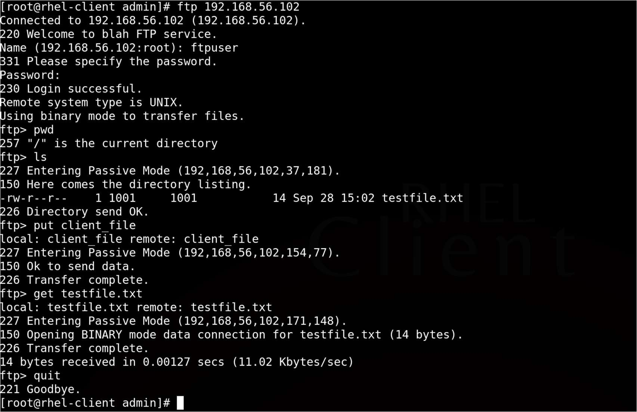

Login as ftpuser



Uploading file



Downloading file

On Sever, you should see the file as “client_file” inside ftpuser home dir

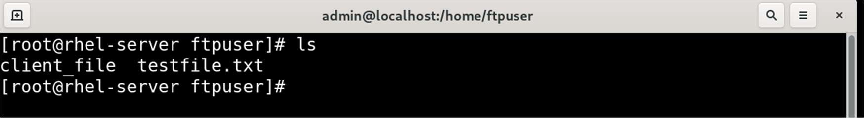

On Client, You should see the file as “testfile.txt” in current working dir

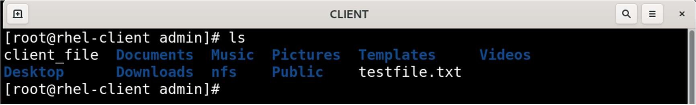

**Practical 8**

Aim: To configure a Samba server on a Linux system and access shared directories from Linux/Windows

Part A: Setup Anonymous (Guest) Samba Share

Step 1: Install Samba Packages

yum install samba samba-common samba-client -y

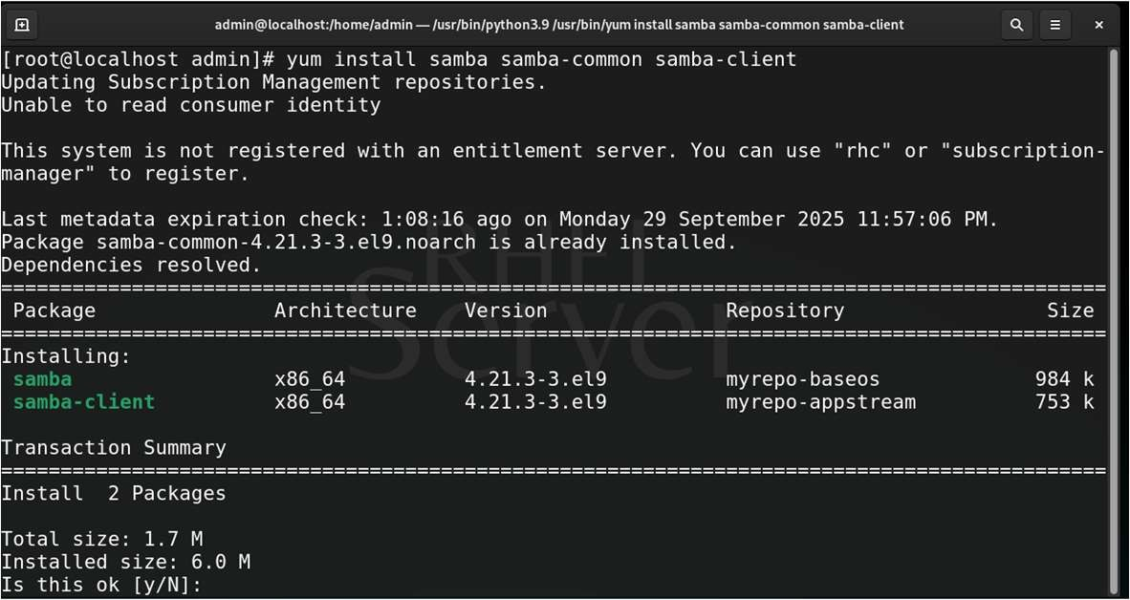

Step 2: Create a Shared Directory and Set Permissions

mkdir /smbshare

chmod 2770 /smbshare/

chcon -t samba_share_t /smbshare/

Verify:

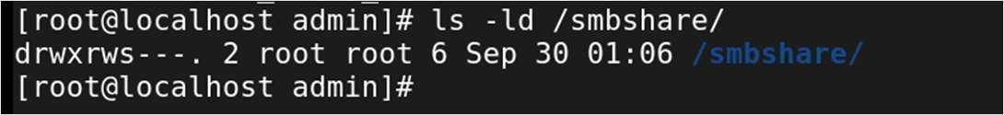

chmod 2770 ensures only group members can write, and setgid maintains group ownership.

Step 3: Edit Samba Configuration File

gedit /etc/samba/smb.conf

Append the following configuration:

|  |
| --- |
| [global]  workgroup = WORKGROUP netbios name = rhel-9 security = user map to guest = bad user dns proxy = No    [Apps]  comment = SMN SHARE path = /smbshare browsable = Yes writable = Yes read only = No guest ok = Yes guest only = Yes |

Step 4: Check Configuration

testparm

Ouput:

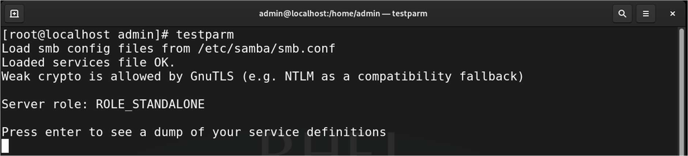

Step 5: Start Samba Services

service smb start service nmb start

Step 6: Enable Firewall Rules

firewall-cmd --permanent --add-service=samba firewall-cmd --reload

Step 7: Access from Windows Client

On the Windows system:

* Open PowerShell as Administrator and run:

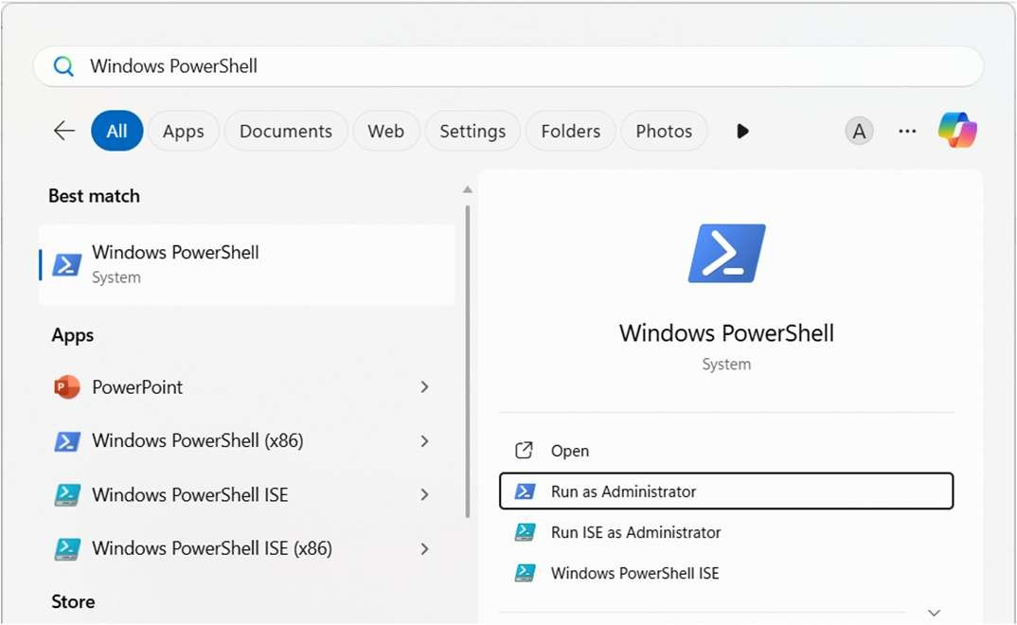

* Run this command in PowerShell

Set-SmbClientConfiguration -RequireSecuritySignature $false

* Press Y to confirm.

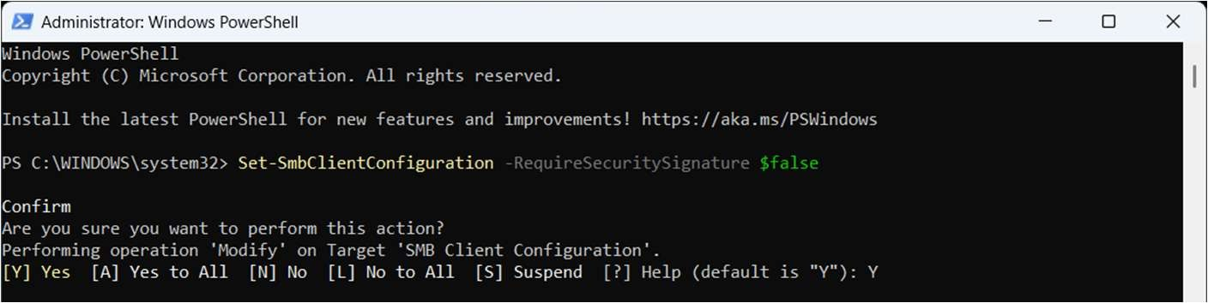

* Press Windows + R and type:

\\<RHEL_IP_ADDRESS>\Apps

* Press Enter to access the share without a password.

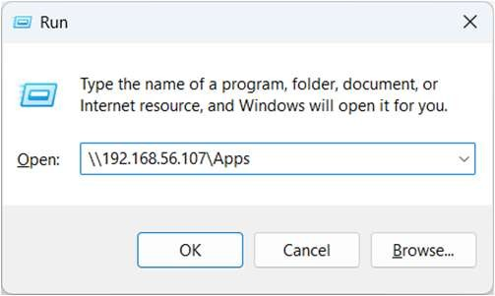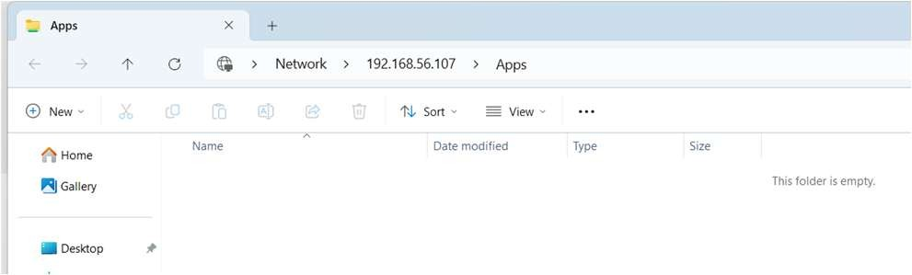

Part B: Setup Secure Samba Share

Step 1: Create Samba Group

groupadd sambagrp

Step 2: Add Admin User

usermod -aG sambagrp admin

Verify: Using id admin



Set Samba Password

smbpasswd -a admin

smbpasswd -e admin

Output:

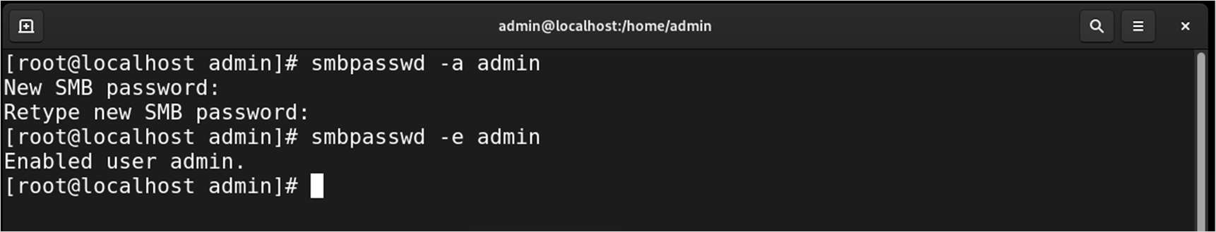

This sets a Samba password separate from the Linux login password.

Step 3: Edit /etc/samba/smb.conf Again

gedit /etc/samba/smb.conf

Update the Apps section:

[Apps]

comment = SMN SHARE path = /smbshare browsable = Yes writable = Yes read only = No guest ok = No valid users = @sambagrp Step 4: Restart Samba Services

service smb restart service nmb restart

Part C: Accessing Secure Share from Linux Machine Step 1: Install Samba-Client & CIFS Utilities

yum install samba-client cifs-utils -y

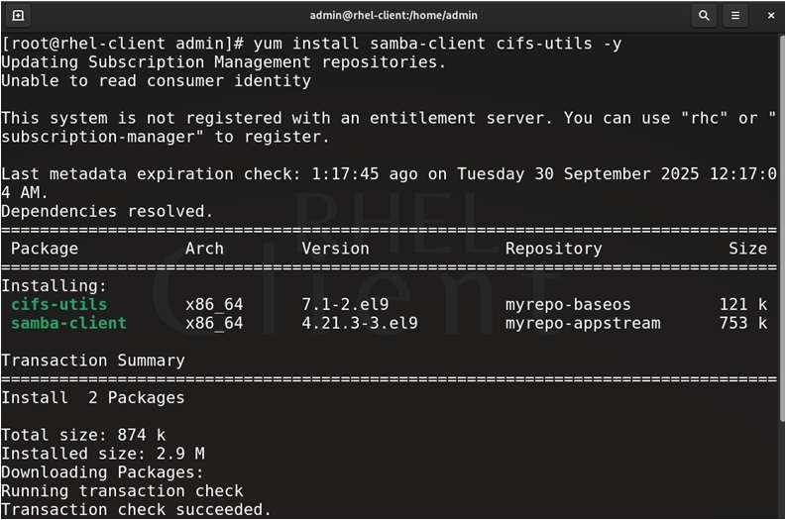

Step 2: Create a Mount Point

mkdir /mnt/smbshare

Step 3: Mount the Samba Share

mount -t cifs //SERVER_IP/Apps /mnt/smbshare username=admin

Output:



* Replace SERVER_IP with the actual IP address of the RHEL Samba server & Replace admin with your Samba user.
* Enter YourSambaPassword for the admin

Step 4: Verify Mount

df -h | grep smbshare

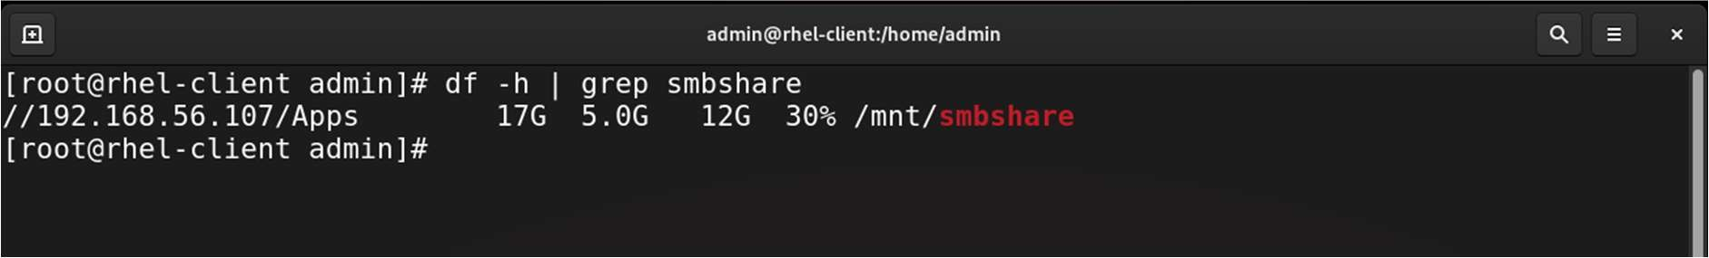

Verify: Create a file inside /mnt/smbshare folder and you can see same file on server inside /smbshare folder

**Practical 9**

Aim: Configuring a DHCP Server

Prerequisites

* Disabling DHCP Server on Host-Only Adapter in Oracle VirtualBox

In VirtualBox Manager: Click on File > Tools > Network Manager > Select your Host-Only Adapter > Uncheck “Enable Server” > Click Close.

* Two Linux systems:

o One to act as the DHCP Server o One to act as the DHCP Client

* Both systems must be on the same adapter (Host Only Adapter) and able to communicate

Step 0: Assign IP Address to Server

ip addr add 192.168.56.2/24 dev enp0s3 ip route add default via 192.168.56.1 service NetworkManager restart

Step 1: Install the DHCP Server Package

Install the DHCP server package using YUM:

yum install dhcp-server -y

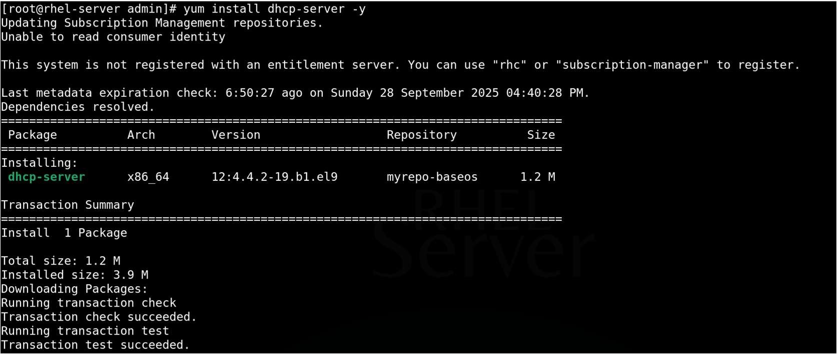

Step 2: Configure the DHCP Server

1. Open the DHCP configuration file for editing:

gedit /etc/dhcp/dhcpd.conf

Add or update the following parameters in the configuration file:

|  |  |
| --- | --- |
| subnet 192.168.56.0 netmask 255.255.255.0 { range 192.168.56.200 192.168.26.230; | # IP address pool for clients |
| option routers 192.168.56.1; | # Default gateway IP address |
| option subnet-mask 255.255.255.0; default-lease-time 600; max-lease-time 7200;  } | # Subnet mask |

Step 3: Restart and Verify the DHCP Service

Restart the DHCP service to apply the configuration changes:

service dhcpd restart

Check the status of the DHCP service to confirm it is running without errors:

service dhcpd status

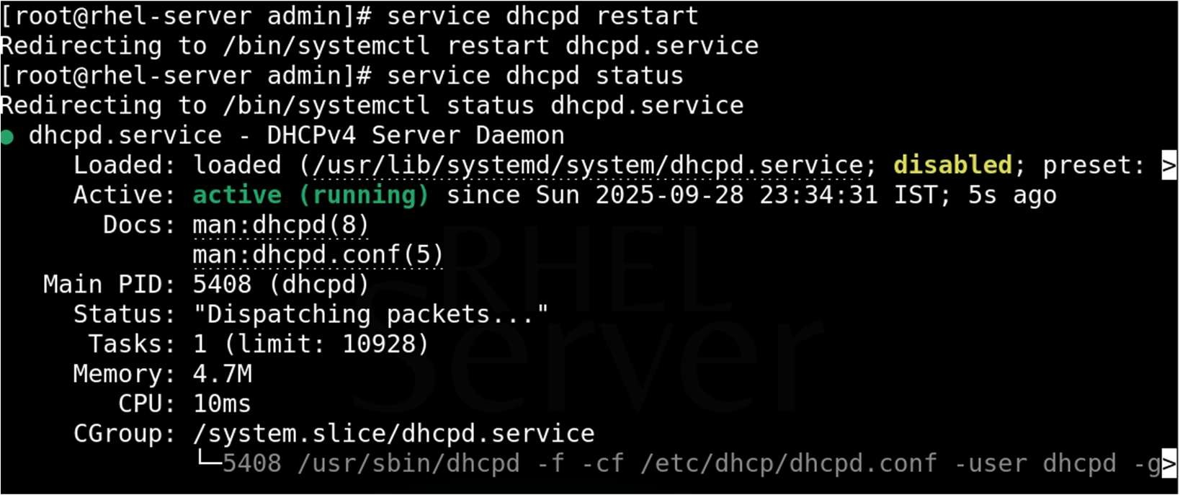

Step 4: Test the DHCP Server

On a client machine connected to the same network, configure the interface to obtain an IP address dynamically.

Once the client acquires an IP, verify that the assigned address falls within the configured DHCP range (192.168.16.200 to 192.168.16.230).

Check IP Address on Client Machine:

ifconfig

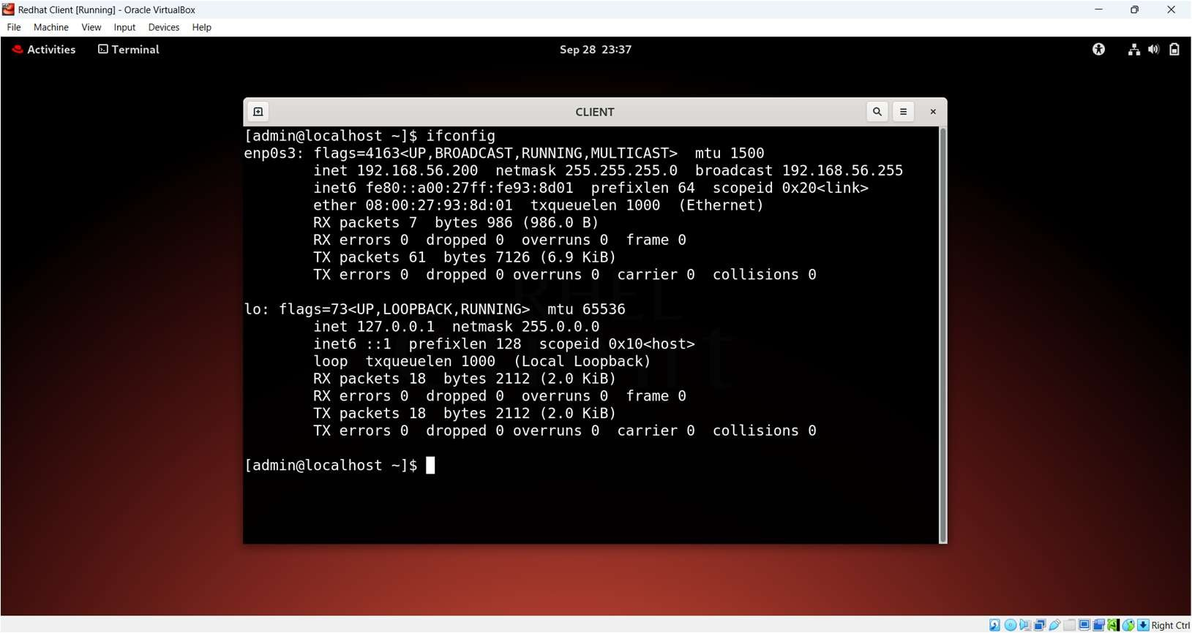

Step 5: Check lease file on server to verify the leased IP Address and the client

# cat /var/lib/dhcpd/dhcpd.leases

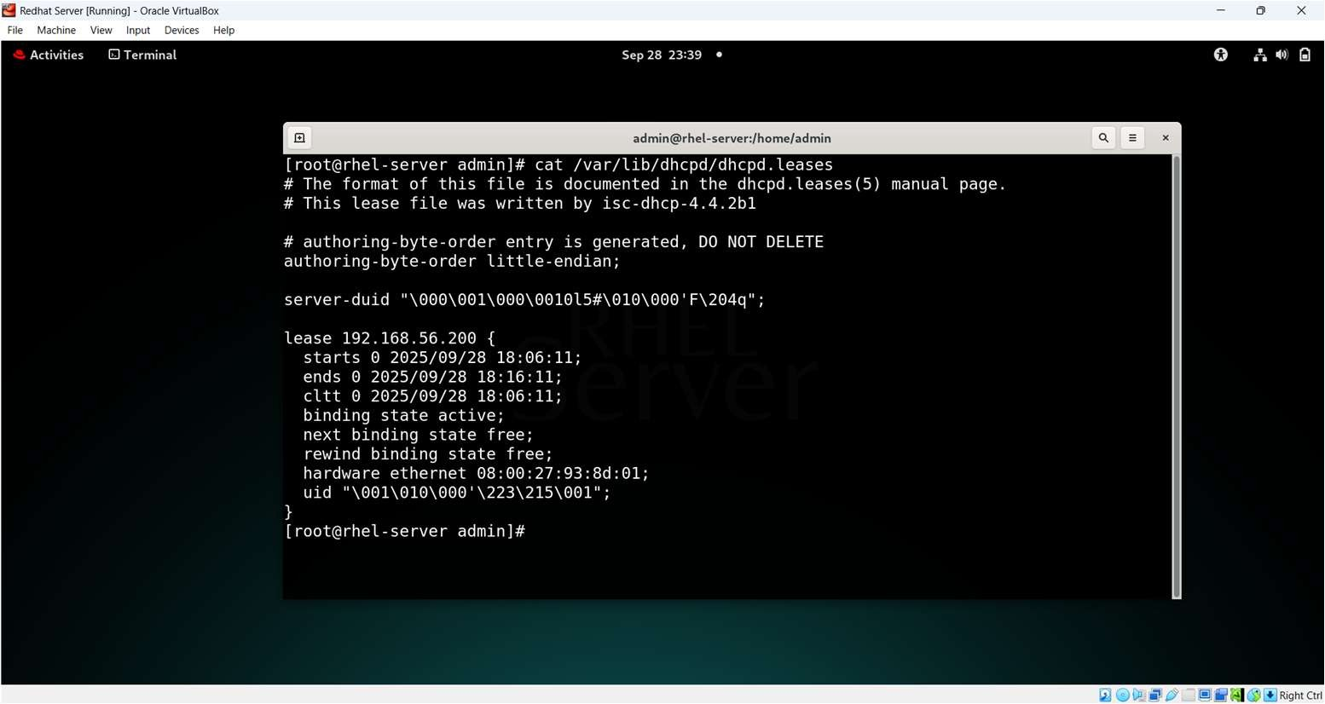

**Practical 10**

AIM: Configuring a Web Server

**Part 1:**

Step 1: Install Apache Web Server

yum install httpd -y

Step 2: Start and Enable Apache Service

Start the Apache service and enable it to start automatically on boot:

service httpd start

Step 3: Adjust Firewall to Allow HTTP Traffic

Allow HTTP (port 80) traffic through the firewall:

sudo firewall-cmd --permanent --add-service=http sudo firewall-cmd --reload

Step 4: Verify Apache is Running Check the status of Apache:

service httpd status

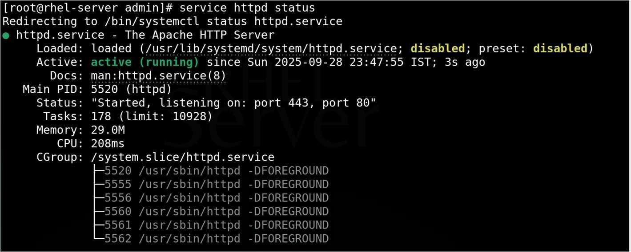

Step 5: Place Your Website Content

By default, the web root directory is: /var/www/html/

Create a Basic HTML Page in Web Root Directory

echo "<h1>Welcome to My Web Server</h1>" | sudo tee /var/www/html/index.html

Verify Using : ls /var/www/html

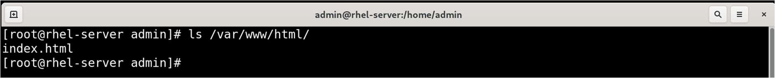

Step 6: Test the Web Server

Open a web browser on Client Machine and navigate to the server’s IP address or hostname:

http://192.168.56.2/

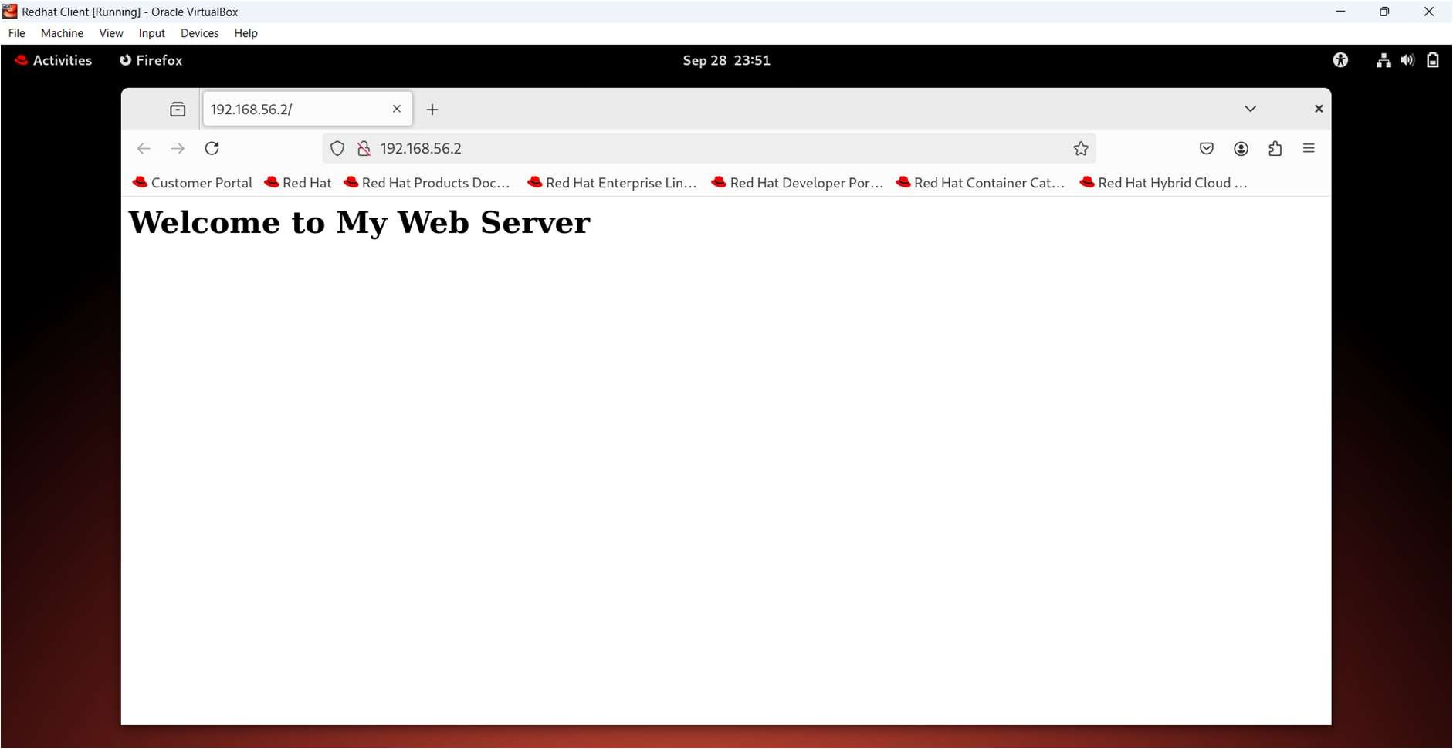

T.Y.B.SC.(I.T.) Linux Server Administrator 2025-26

**Part 2**: Setting Up Virtual Host on Web Server

Step 1: Create Directory for Your Website

Create a directory for your new website under /var/www/. For example, for example.com:

mkdir -p /var/www/example.com/public_html

Set proper permissions:

# chmod -R 755 /var/www/example.com

Step 2: Create a Test Index Page Add a simple HTML file to test:

gedit /var/www/example.com/public_html/index.html

add the following html code:

# <h1>Welcome to example.com!</h1> <h2> This is Virtual Host <h2>

Step 3: Create Virtual Host Configuration File

Create a new configuration file for your site in /etc/httpd/conf.d/, e.g., example.com.conf:

gedit /etc/httpd/conf.d/example.com.conf

Add the following content:

# <VirtualHost *:80> ServerName example.com ServerAlias www.example.com DocumentRoot /var/www/example.com/public_html </VirtualHost>

Step 4: Test Apache Configuration Check for syntax errors:

# apachectl configtest

If syntax is OK, proceed.

Step 5: Restart Apache Service

Restart Apache to apply the new virtual host:

service httpd restart

Step 6: Update Your DNS or Hosts File

For testing locally, add an entry in /etc/hosts on your client machine:

gedit /etc/hosts

Add:

192.168.x.x example.com www.example.com

Replace 192.168.x.x with your web server’s IP address.

Step 7: Test Your Virtual Host Open a browser and visit:

http://example.com

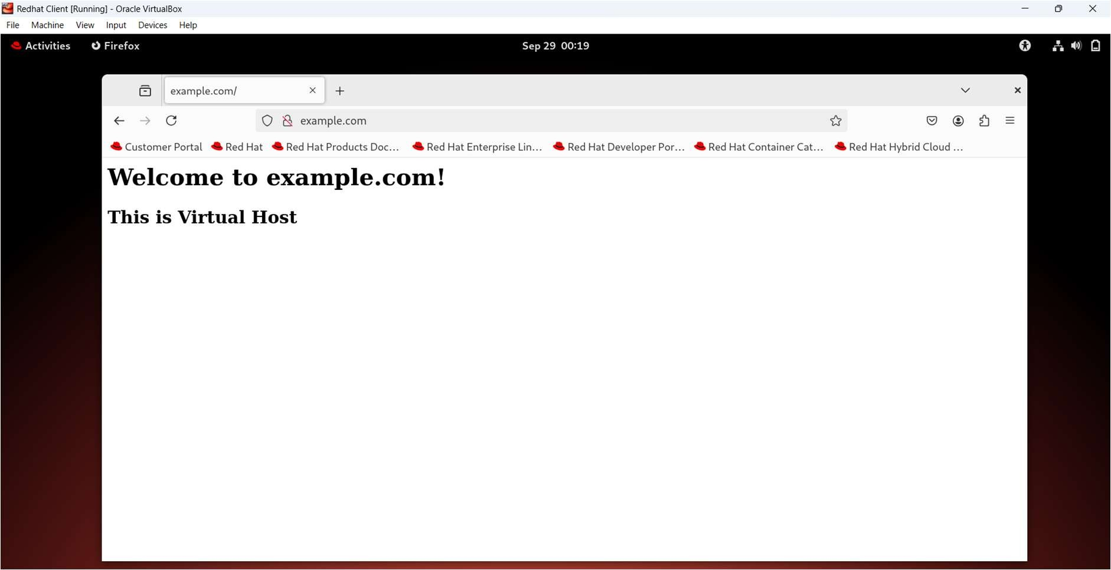

You should see the custom welcome page you created.

**Practical 11**

Aim: Configure Mail Server using Sendmail.

Step 1: Install Required Packages

yum install sendmail sendmail-cf s-nail -y

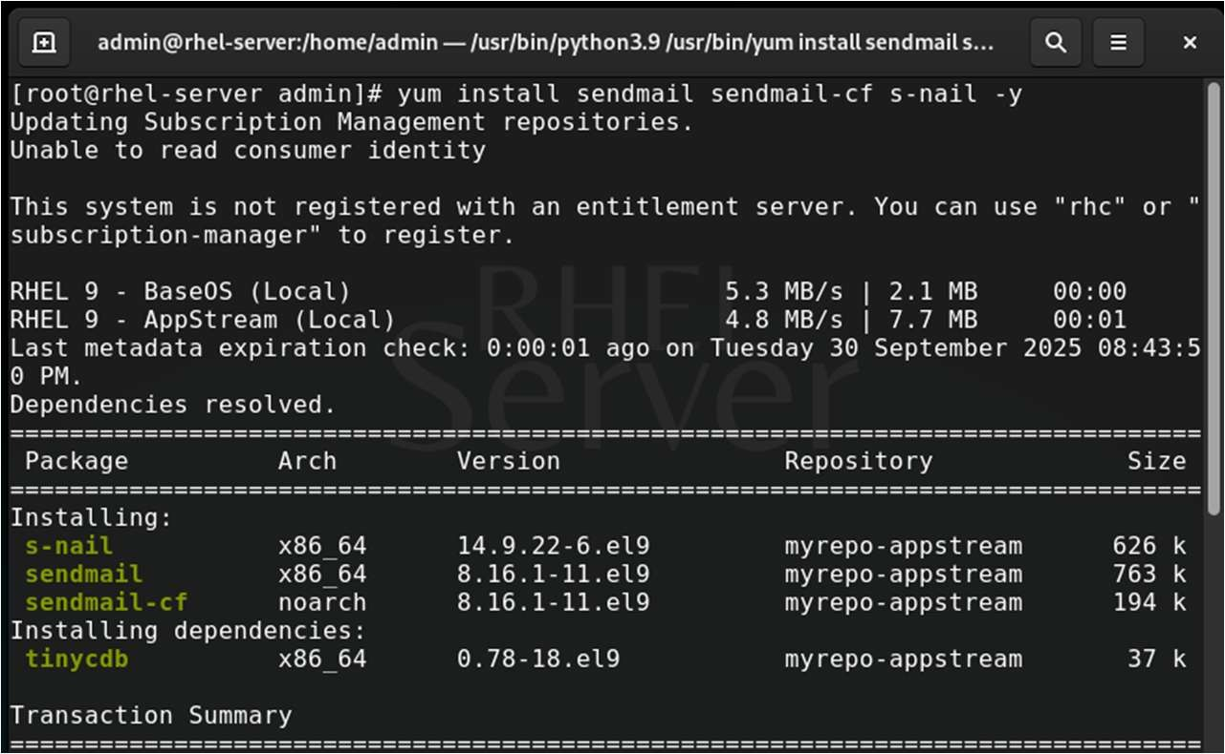

Explanation:

* sendmail: Mail Transfer Agent (MTA)
* sendmail-cf: Configuration files for sendmail
* s-nail: Mail client (used to read/send mail)

Step 2: Start Sendmail Service

service sendmail start service sendmail status

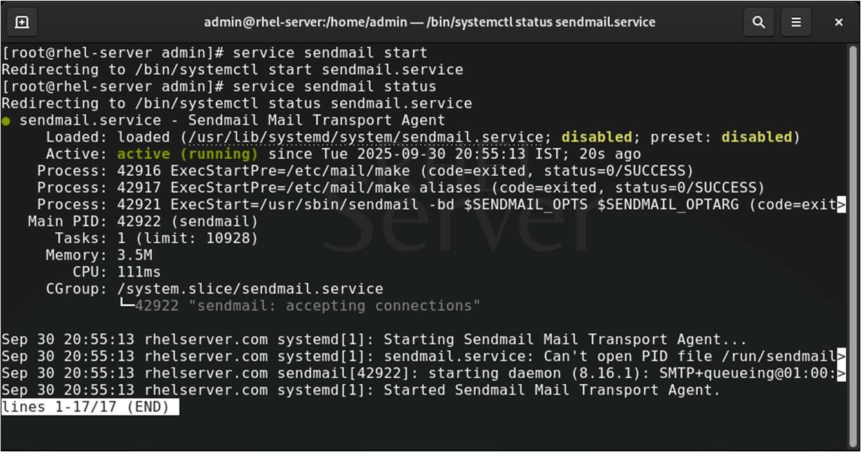

Step 3: Create Two Local Users (Alice and Bob) Create users alice and bob:

useradd alice useradd bob passwd alice passwd bob

Step 4: Send Mail from Alice to Bob

Switch to alice user and send mail to bob:

su - alice

Now, send the mail:

echo "Hello Bob, this is Alice." | mail -s "Test Mail from Alice" bob

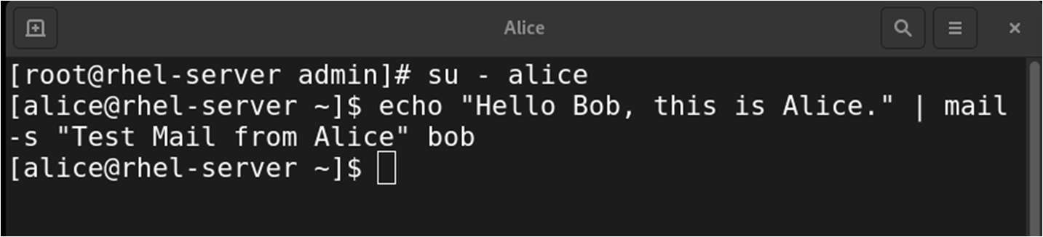

Type exit to return to root.

Step 5: Switch to Bob and Read/Reply to Mail Switch to bob user:

su - bob

Check mail:

mail

* You should see the message from Alice.

* To open it, just press the message number (usually 1) and press Enter.

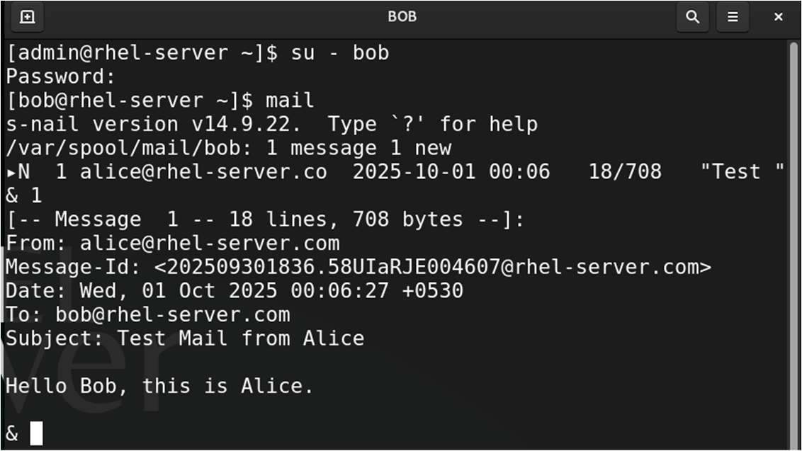

* To reply type r then type your message and press Ctrl + D. Then Type Yes and press enter to send

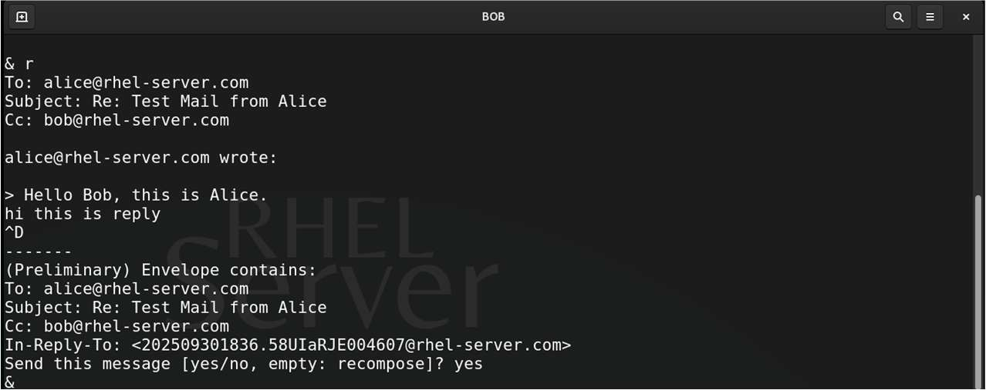

* After reading the mail, note down the sender and exit mail client by typing: q • Now Send a New Mail:

echo "Hello Alice, got your message." | mail -s "Reply from Bob" alice

* Exit bob's shell:
* exit

To Check Reply (Back as Alice)

su - alice mail

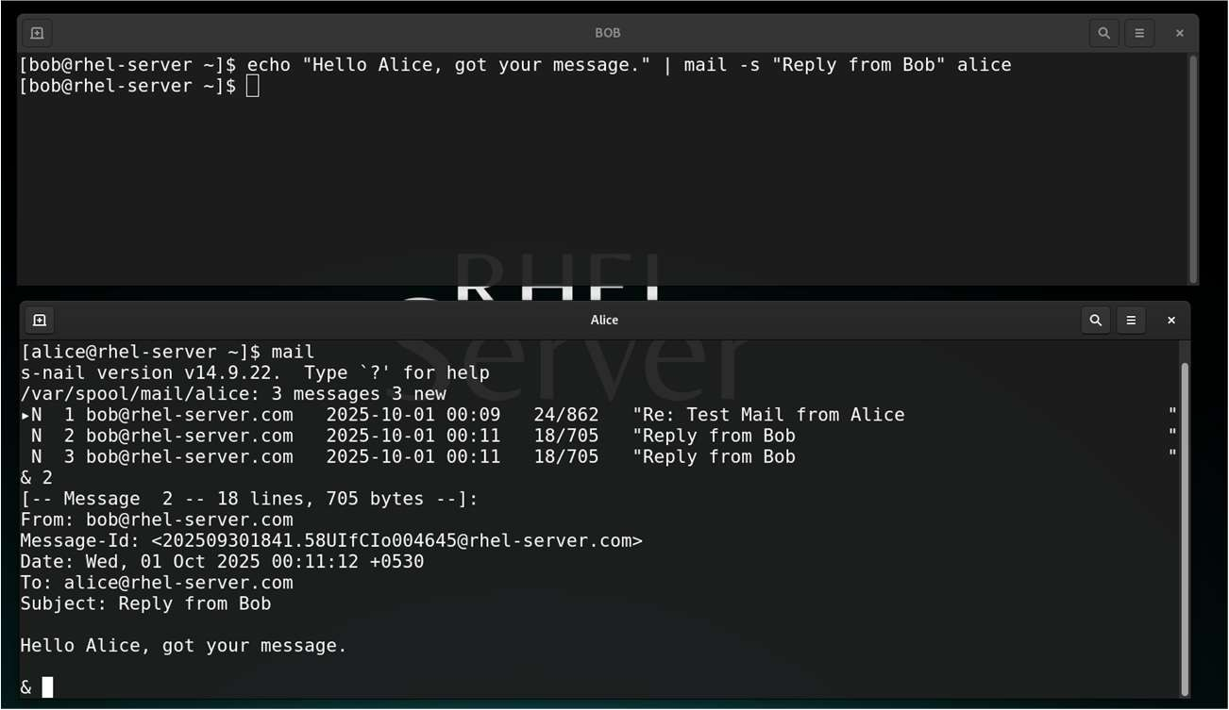

**Practical 12**

Aim: Configure cron, anacron, and AT.

Part A: Working With Cron

Objective: To create a shell script that sends an email message from a normal user to the root user every 1 minutes using a cron job on a RHEL system.

Step 1: Create the Shell Script

Log in as admin, and create a shell script:

gedit send_email.sh

Paste the following into it:

#!/bin/bash

SUBJECT="Cron Job Email"

DATE_TIME=$(date)

DISK_USAGE=$(df -h)

BODY=" Current Date and Time: $DATE_TIME

Disk Usage Report:

/----------------------------------------/

$DISK_USAGE

/----------------------------------------/"

echo -e "Subject: $SUBJECT\n\n$BODY" | /usr/sbin/sendmail root SUBJECT="Cron Job"

Set Execute Permission

chmod +x /home/admin/send_email.sh

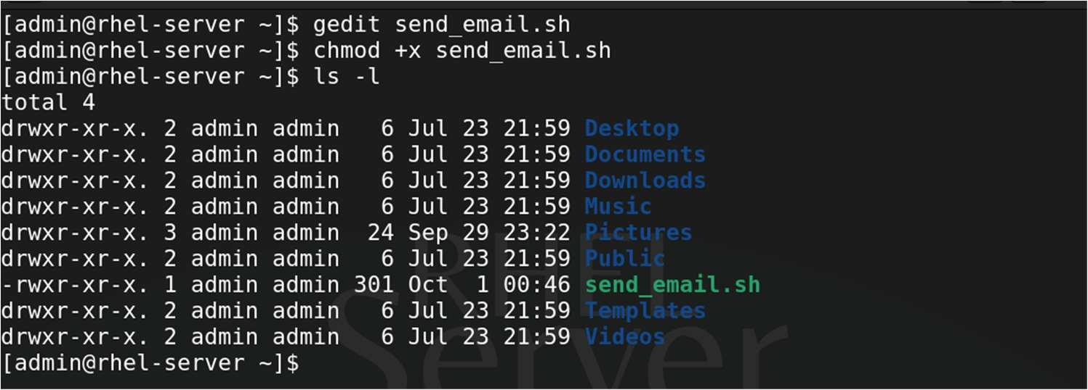

Step 2: Schedule It with Cron Edit admin crontab:

crontab -e

Add this line to run the script every 1 minutes:

Press i to insert

* * * * * /home/admin/send_email.sh

Press :wq to save and quit

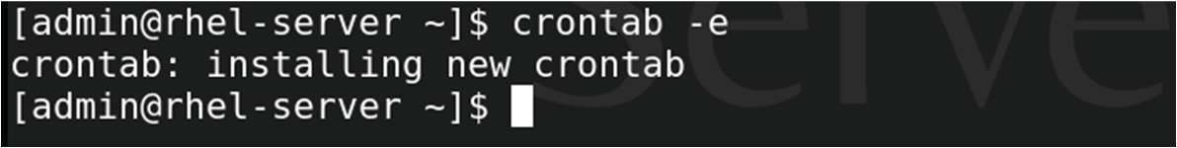

Verify the cronjobs using : crontab -l

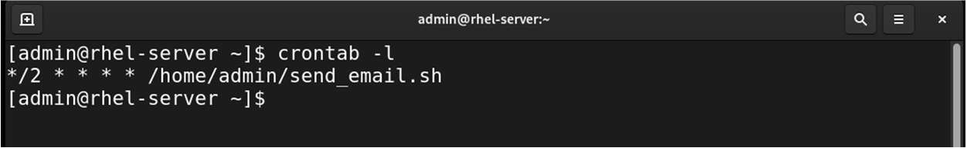

Step 3: Verify It Works

Wait 1 minutes, then check root's mail:

su - # Become root

mail # View mail

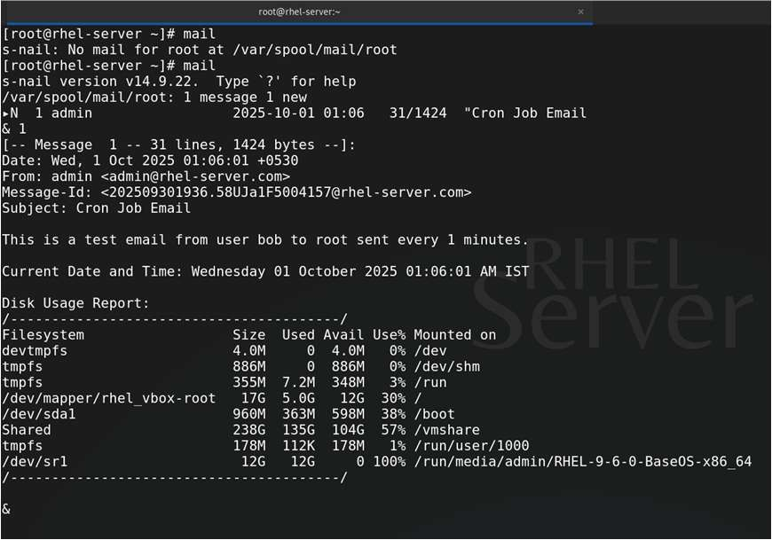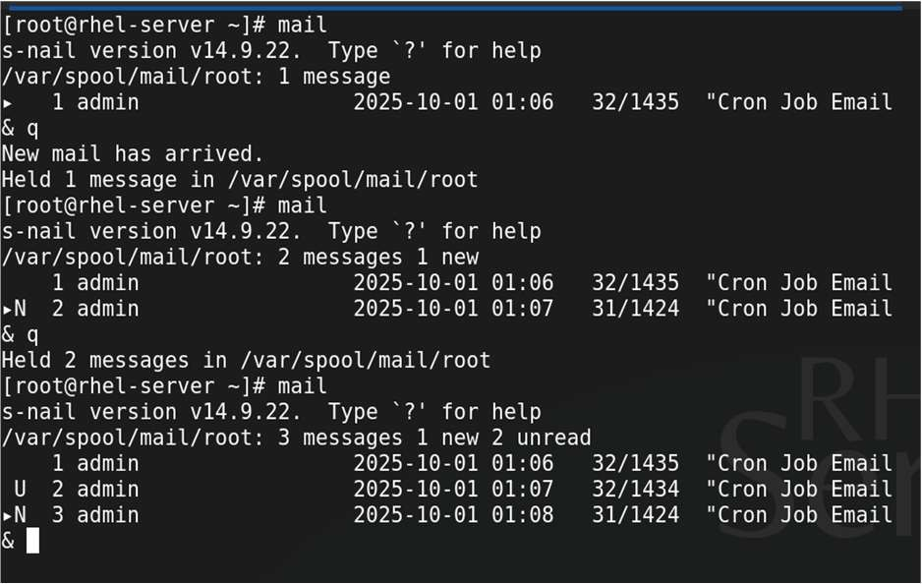

To Delete the User’s Cron Job Use the Command:

# crontab -r

Part B: Working With Anacron

We have already created a script called send_email.sh in Part A. Step 1: Verify the Script Exists and is Executable

ls -l /home/admin /send_email.sh

Make it executable if it isn’t:

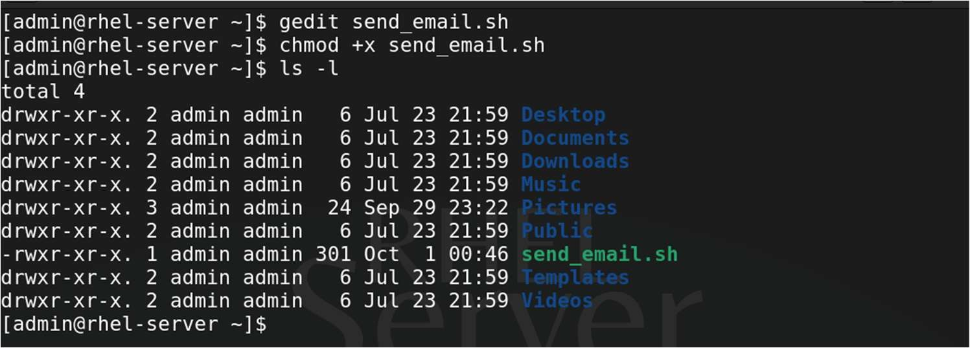

chmod +x /home/admin/send_email.sh

Step 2: Add a Custom Entry in /etc/anacrontab

gedit /etc/anacrontab

Add the following line at the bottom:

1 5 send_email_job /home/admin/send_email.sh

|  |  |
| --- | --- |
| Field | Description |
| 1 | Frequency: run once every 1 day |
| 5 | Delay: wait 5 minutes after system startup |
| send_email_job | Unique job identifier |
| /home/admin/send_email.sh | Full path to your script |

Step 3: Start Anacron Service

service anacron start

Check its status:

service anacron status

Step 4: To simulate Anacron running the job without waiting:

# anacron -f

This forces Anacron to run all due jobs immediately (useful for testing)

Part C: Working With AT

To schedule the previously created send_email.sh script to run once at a specified time using the at command.

Step 1: Install at and Enable the Service (if not already)

# yum install at -y

Step 2: Enable and start the atd service:

systemctl enable --now atd

Step 3: Schedule the Script Using at

To run the script at a specific time, For Example 5 mins after from now

at now + 5 minutes

You’ll get a prompt like:

at >

Then type the full command to run your script:

# bash /home/admin/send_mail.sh

Then press Enter, then Ctrl + D to exit the prompt.

Step 4: Verify the Scheduled Job

To see pending at jobs:

# atq

Each job has a job number (e.g., 1).

Step 5: Remove a Scheduled Job (Optional) If you want to cancel a scheduled job:

atrm <job_number>

Example:

# atrm 1

**Practical 13**

Aim: Securing Server with iptables

Step 1. Install and start iptables-services

|  |  |
| --- | --- |
| yum install iptables -y  service iptables start | # Start Iptables Services |
| service firewalld stop | # Stop Firewalld Services |
| Step 2. Flush Existing Rules |  |
| iptables -F |  |
| Step 3. Set Default Policies |  |
| iptables -P INPUT DROP iptables -P FORWARD DROP iptables -P OUTPUT ACCEPT |  |
| Step 4. Allow Loopback (localhost) |  |
| iptables -A INPUT -i lo -j ACCEPT | |

Step 5. Allow SSH (Port 22)

# iptables -A INPUT -p tcp --dport 22 -j ACCEPT

Step 6. Allow HTTP and HTTPS (Ports 80, 443)

iptables -A INPUT -p tcp --dport 80 -j ACCEPT iptables -A INPUT -p tcp --dport 443 -j ACCEPT

Step 7. Allow ICMP Ping

# iptables -A INPUT -p icmp --icmp-type echo-request -j ACCEPT

Step 8. Block a Specific IP (Example)

iptables -A INPUT -s 192.168.1.100 -j DROP

Step 9. Save the Rules

service iptables save

Step 10. Restart the Firewall

service iptables restart

Step 11. Check and Verify All the Rules

# iptables -L -n --line-numbers

Step 12: Delete rule using line-numbers Deleting Rule number 2 in Input Chain

iptables -D INPUT 2

Save the Changes

# service iptables save

**Practical 14**

Aim: Working with GPG (Cryptographic Services)

Objective:

Enable secure communication and file exchange between two users (Lisa and Linda) using GPG for encryption, decryption, signing, and verification.

Step 1: Create User’s Lisa and Linda

useradd lisa useradd linda passwd lisa passwd linda

verify :

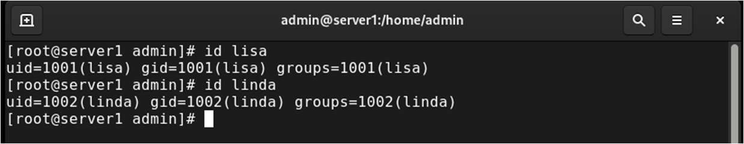

Step 2: Generate GPG Key Pairs

Generate gpg keys for both the users

First Login as linda and generate keys then login as lisa and repeat this steps.

gpg --full-generate-key

* Key-type: Press 1 for (RSA) and hit enter
* Key size: 4096
* Expiry: 0 (never)
* Then press Y to confirm the details
* Enter Real and Email and Comment if any and press O to Confirm
* Set a secure passphrase when prompted

Step 2: Export Public Keys

Exports public key for each user’s using command:

gpg --export linda@server1.local > /tmp/linda_pub.asc

Repeat Same for lisa

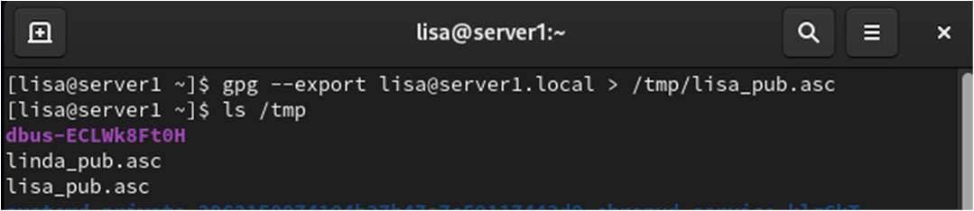

Step 3: Import public keys

Linda Imports Public key of Lisa and vice versa using command For Linda

gpg --import /tmp/lisa_pub.asc

For Lisa

gpg --import /tmp/linda_pub.asc

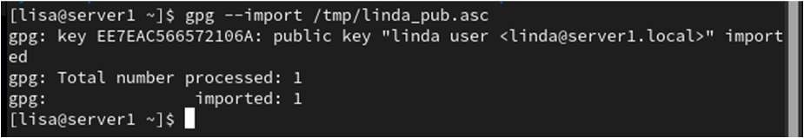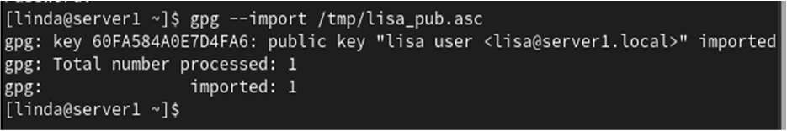

Step 4: Check all public key list

gpg –list-keys

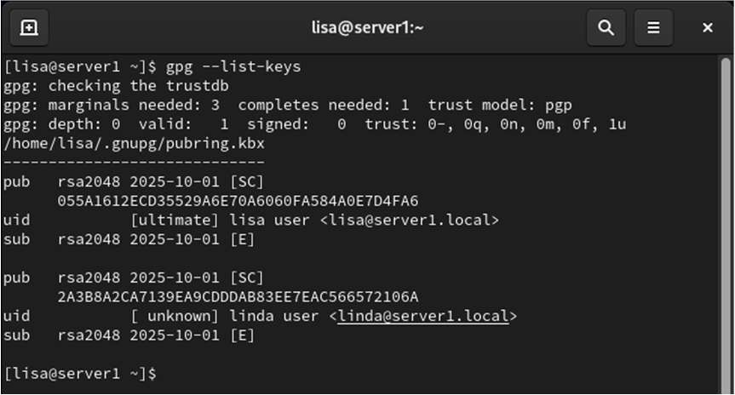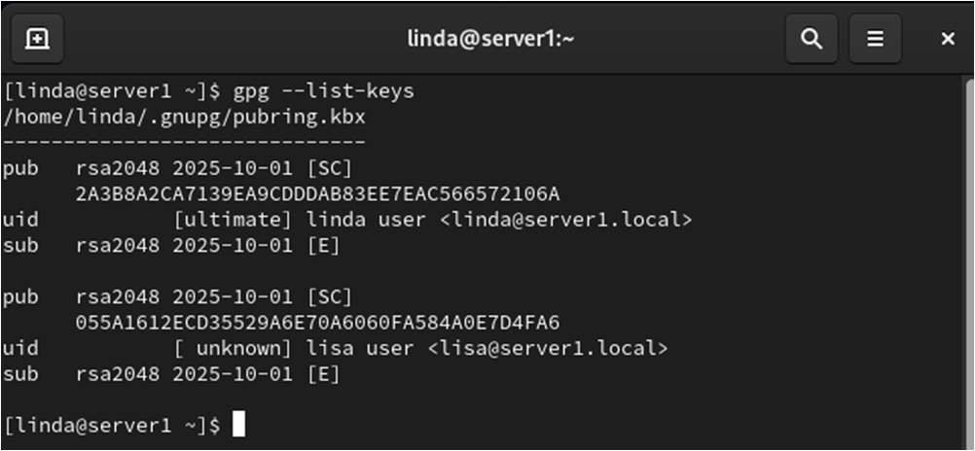

Step 5: Encrypt file using gpg key Lisa Create a File Msg.txt and Encrypts

echo “hi this is lisa” >> Msg.txt gpg -e -r linda@server1.local Msg.txt

Here -e → Encrypts -r → recipient

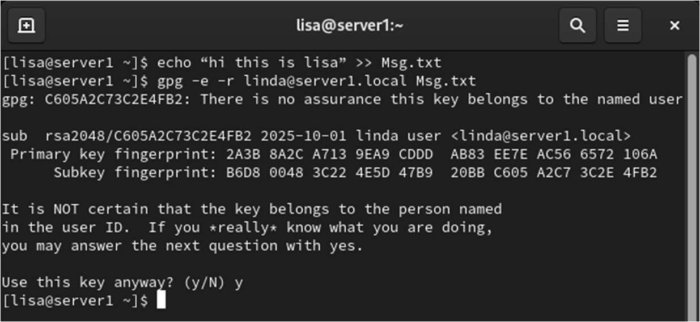

Press Y to confirm the recipient

Type ls and you will find the encrypted filed with the name as Msg.txt.gpg

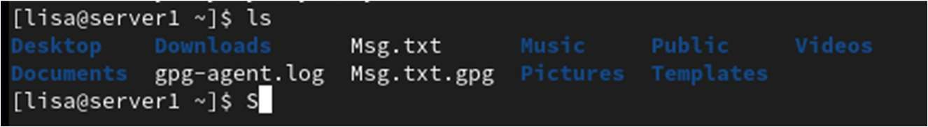

Move Msg.txt.gpg to /tmp/ so that Linda can access the file

mv Msg.txt.gpg /tmp/Msg.txt.gpg

Step 6: Decrypt the File using gpg key

Now, Linda Decrypts the file which was created by lisa

gpg -o decrypted.txt -d /tmp/Msg.txt.gpg

verify using ls and cat command:-

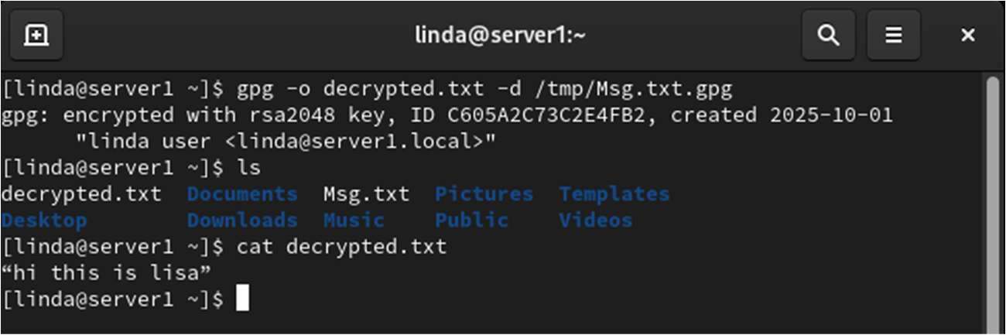

To Sign any file use command as below:

gpg --clearsign secret.txt

To Verify the Signature:

# gpg --verify secret.txt.asc

To Delete Secrete Key

gpg --delete-secret-key --yes lisa@server1.local

To Delete Public Key

gpg --delete -key --yes lisa@server1.local

**Practical 15**

Aim: Programs on Shell scripting

Steps to Create and Run a Shell Script

1. Create a script file:

gedit myscript.sh

Type the script, save and close.

1. Make it executable:

chmod +x myscript.sh

1. Run it:

./myscript.sh

1. Script Check if a Number is Even or Odd.

#!/bin/bash read -p "Enter a number: " num if (( num % 2 == 0 )); then echo "$num is Even" else echo "$num is Odd" fi

1. Simple Calculator

|  |
| --- |
| #!/bin/bash echo "Enter two numbers:" read a read b    echo "Choose operation: + - * /" read op    case $op in  +) echo "Result: $((a + b))" ;;  -) echo "Result: $((a - b))" ;;  \*) echo "Result: $((a * b))" ;; # Escape * with \  /) echo "Result: $((a / b))" ;; *) echo "Invalid operator" ;; esac |

1. Factorial of a Number (Using Loop)

|  |
| --- |
| #!/bin/bash read -p "Enter a number: " n fact=1    for (( i=1; i<=n; i++ )) do  fact=$((fact * i)) done echo "Factorial of $n is $fact" |

1. User Login Check

|  |
| --- |
| #!/bin/bash read -p "Enter a username: " user if id "$user" &>/dev/null; then  echo "User '$user' exists on the system." else echo "User '$user' does not exist." fi |

1. Create Multiple Users from text file

User.txt

Lisa Linda ftpuser

#!/bin/bash

INPUT="users.txt"

while IFS= read -r user do if id "$user" &>/dev/null; then echo "User $user already exists." else useradd "$user" -m echo "User $user created."

fi

done < "$INPUT"

1. Checks if a httpd service is running and restarts it if it's not.

#!/bin/bash

SERVICE="httpd"

if systemctl is-active --quiet $SERVICE; then echo "$SERVICE is running." else echo "$SERVICE is not running. Attempting to restart..." systemctl restart $SERVICE echo "$SERVICE restarted."

fi

1. Script to create a counter and display the counter

#!/bin/bash

COUNTER_FILE="counter.txt"

if [ ! -f "$COUNTER_FILE" ]; then echo 0 > "$COUNTER_FILE"

fi

count=$(cat "$COUNTER_FILE") count=$((count + 1)) echo "$count" > "$COUNTER_FILE"

echo "Counter: $count"

1. Simple RPM Query Script

|  |
| --- |
| #!/bin/bash read -p "Enter the RPM name or full path to a file: " name echo "a. Find the RPM from which this file originates" echo "b. Check if the RPM is installed" echo "c. Install this RPM" echo "d. Remove this RPM" read -p "Enter your choice (a/b/c/d/e): " choice case $choice in   1. rpm -qf "$name";; 2. rpm -q "$name";; 3. sudo yum install "$name" -y ;; 4. sudo rpm -e "$name" ;; *)echo "Invalid choice.";; esac |